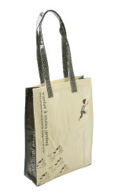 | SER_PC1-04 | PVC Bag_Help | 0.30 | SER | 5,250YEN  (232)  (140) | 220-250 NIS
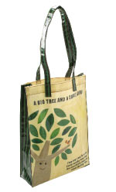 | SER_PC1-06 | PVC Bag_Close friends | 0.30 | SER | 5,250YEN
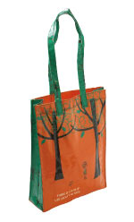 | SER_PC1-10 | PVC Bag_tree | 0.30 | SER | 5,250YEN
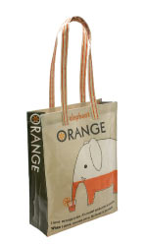 | SER_PC1-13 | PVC Bag_Orange | 0.30 | SER | 5,250YEN

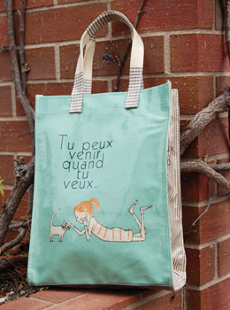 | SER_spc2-04 | PVC Bag Cheri_itudemooide | 0.20 | SER | 2,940YEN
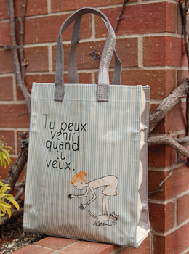 | SER_spc2-05 | PVC Bag Cheri_cheri & cat | 0.20 | SER | 2,940YEN  (130)  (78) | 130-180 NIS
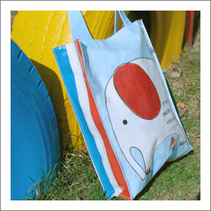 | ANN_71405 | PVC Bag_elephant | 0.30 | ANN | 2,100YEN  (93)  (56)
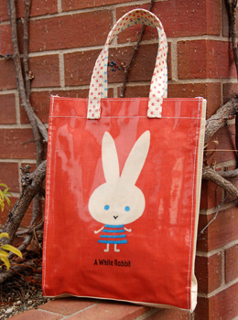 | SER_spc1-01 | PVC Bag Mon Peluche_jiji & peren | 0.20 | SER | 2,940YEN
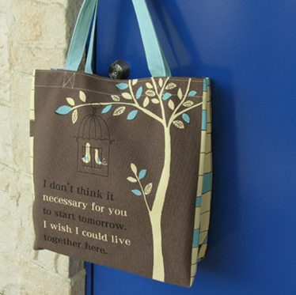 | SER_CT4-64 | Tote Bag_under the tree | 0.40 | SER | 2,625YEN  (116)  (70) | 170-270 NIS
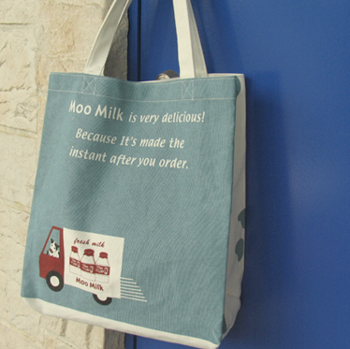 | SER_CT4-61 | Tote Bag_moo milk | 0.40 | SER | 2,625YEN
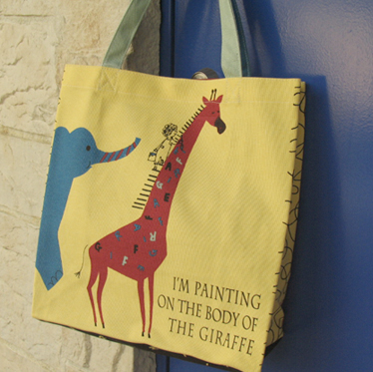 | SER_CT4-63 | Tote Bag_giraffe | 0.40 | SER | 2,625YEN
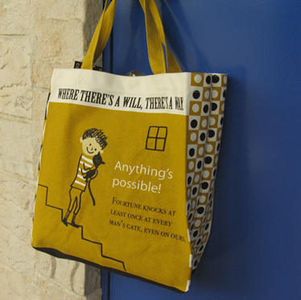 | SER_CT4-58 | Tote Bag_ｂｏｙ&ｃａｔ | 0.40 | SER | 2,625YEN
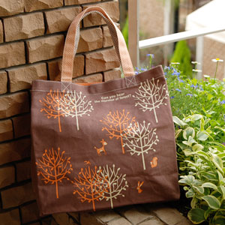 | SER_CT4-85 | Tote Bag_mori | 0.40 | SER | 2,625YEN
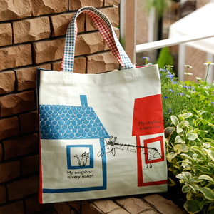 | SER_CT4-84 | Tote Bag_my neighbor | 0.40 | SER | 2,625YEN
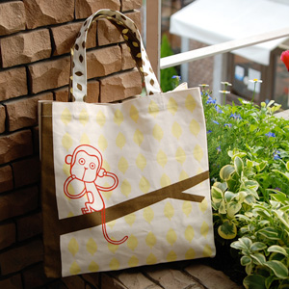 | SER_CT4-87 | Tote Bag_osaru | 0.40 | SER | 2,625YEN
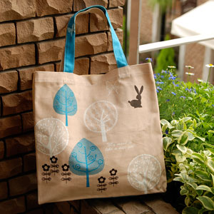 | SER_CT4-73 | Tote Bag_lace | 0.40 | SER | 2,625YEN
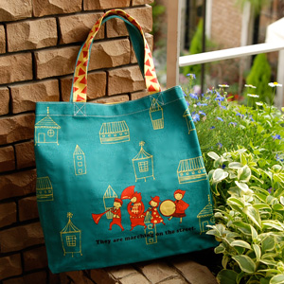 | SER_CT4-72 | Tote Bag_march | 0.40 | SER | 2,625YEN
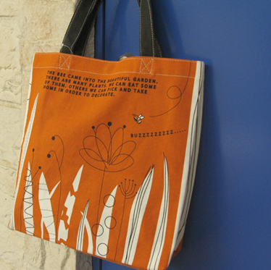 | SER_CT4-62 | Tote Bag_bee & garden | 0.40 | SER | 2,625YEN
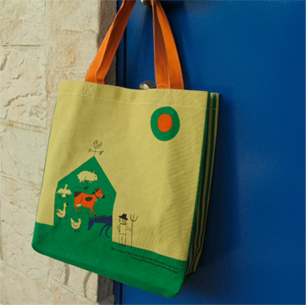 | SER_CT4-56 | Tote Bag_barn | 0.40 | SER | 2,625YEN
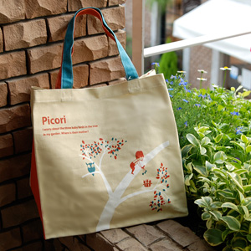 | SER_CT4-75 | Tote Bag_picori | 0.40 | SER | 2,625YEN
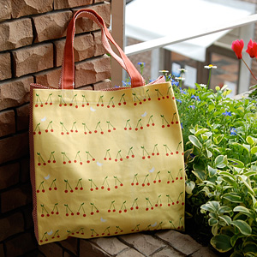 | SER_CT4-81 | Tote Bag_sakuranbo | 0.40 | SER | 2,625YEN
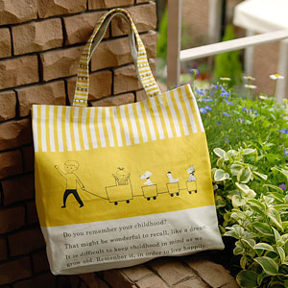 | SER_CT4-80 | Tote Bag_dream | 0.40 | SER | 2,625YEN
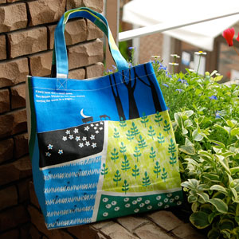 | SER_CT4-68 | Tote Bag_moon | 0.40 | SER | 2,625YEN
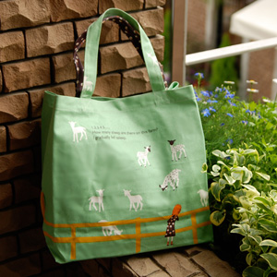 | SER_CT4-74 | Tote Bag_asleep | 0.40 | SER | 2,625YEN
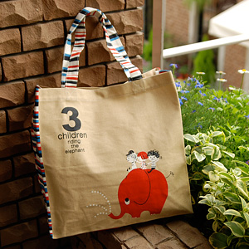 | SER_CT4-70 | Tote Bag_3children | 0.40 | SER | 2,625YEN
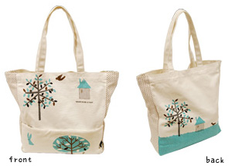 | SKD_BE-TOB | Tote Bag BELLE FLEUR murmur | 0.40 | SKD | 2,100YEN  (93)  (56) | 130-160
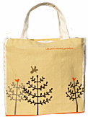 | SER_CT3-55 | ZipperToteBag_branche | 0.45 | SER | 2,940YEN
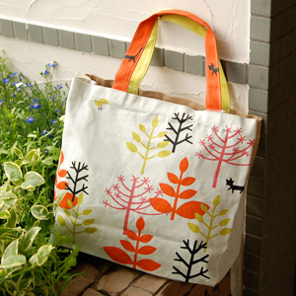 | SER_CT3-90 | ZipperToteBag_colorful tree | 0.45 | SER | 2,940YEN
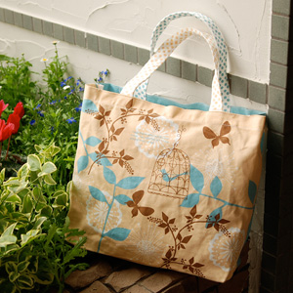 | SER_CT3-97 | ZipperToteBag_flitting | 0.45 | SER | 2,940YEN
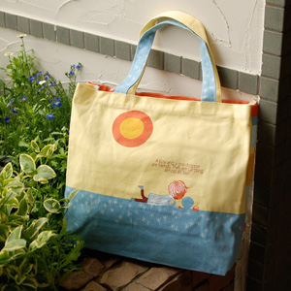 | SER_CT3-98 | ZipperToteBag_glasshopper | 0.45 | SER | 2,940YEN
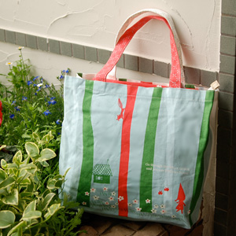 | SER_CT3-91 | ZipperToteBag_go through | 0.45 | SER | 2,940YEN
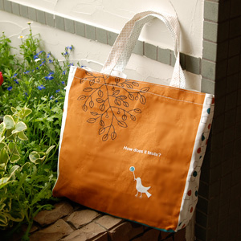 | SER_CT3-95 | ZipperToteBag_tasty | 0.45 | SER | 2,940YEN
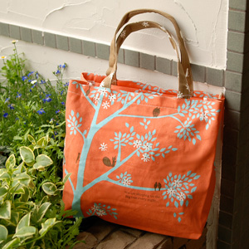 | SER_CT3-99 | ZipperToteBag_night | 0.45 | SER | 2,940YEN
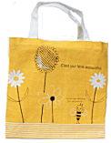 | SER_CT3-44 | ZipperToteBag_fluer | 0.45 | SER | 2,940YEN
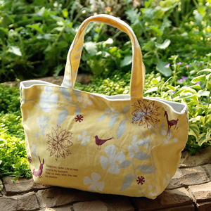 | SER_ST2-46 | Short Tote Bag_shadow | 0.20 | SER | 1,890YEN  (84)  (50) | 120-180 NIS
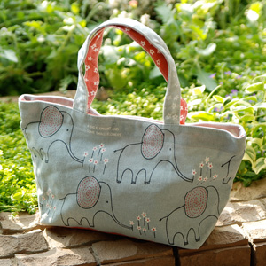 | SER_ST2-49 | Short Tote Bag_pick | 0.20 | SER | 1,890YEN
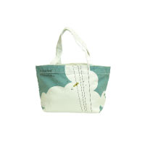 | SER_ST1-29 | Short Tote Bag_Little Bird | 0.20 | SER | 1,890YEN
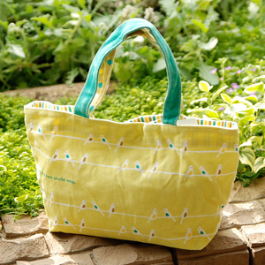 | SER_ST2-48 | Short Tote Bag_kotori | 0.20 | SER | 1,890YEN
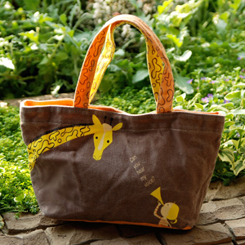 | SER_ST2-47 | Short Tote Bag_hear | 0.20 | SER | 1,890YEN
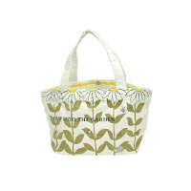 | SER_ST1-08 | Short Tote Bag_Flower Garden | 0.20 | SER | 1,890YEN
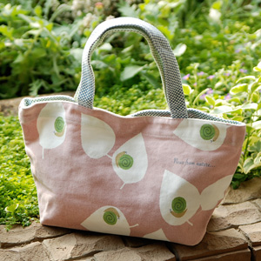 | SER_ST2-41 | Short Tote Bag_denden | 0.20 | SER | 1,890YEN
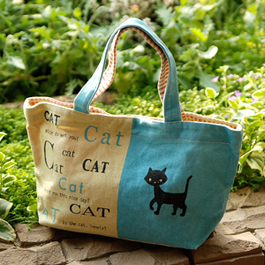 | SER_ST2-40 | Short Tote Bag_cat&dog | 0.20 | SER | 1,890YEN
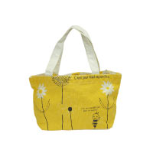 | SER_ST1-09 | Short Tote Bag_Fleur | 0.20 | SER | 1,890YEN

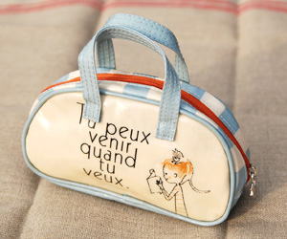 | SER_sph2-05 | PVC Pouch Cheri_cheri&cat | 0.10 | SER | 1,680YEN
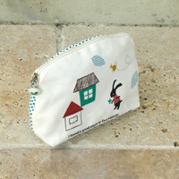 | YAN_sk-921 | Pouch_Hutte | 0.05 | YAN | 1,260YEN
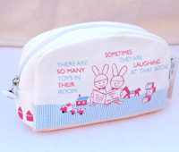 | ZEL_TR-POUCH | Pouch Treasure Box_TR_Rabbits | 0.07 | ZEL | 1,470YEN
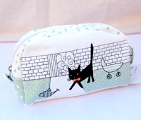 | ZEL_CA-POUCH | Pouch Treasure Box_CA_Cat | 0.07 | ZEL | 1,470YEN
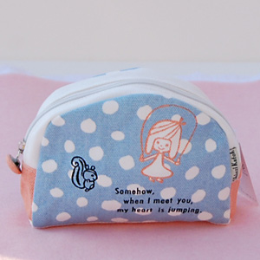 | ANN_71419 | Pouch_jump | 0.07 | ANN | 1,365YEN
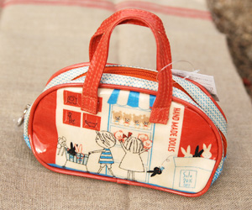 | SER_sph1-02 | PVC Pouch Mon Peluche_shopping | 0.10 | SER | 1,680YEN
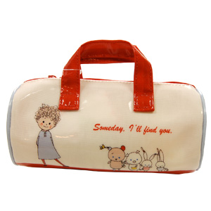 | SEK_881610 | Someday,I'll find you. PVC Handle Pouch Introduce | 0.05 | SEK | 2,310YEN
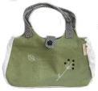 | SER_RT1-21 | Round Bag_ripe | 0.26 | SER | 3,990YEN
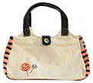 | SER_RT1-02 | Round Bag_mignon | 0.26 | SER | 3,990YEN

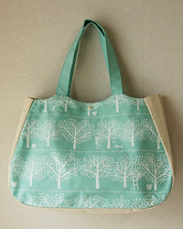 | GSJ_GS-048 | Picnic Bag_Apple Garden | 0.20 | GSJ | 2,940YEN  (130)  (78) | 130-230
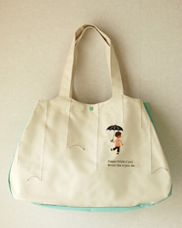 | GSJ_GS-053 | Picnic Bag_Rain | 0.20 | GSJ | 2,940YEN
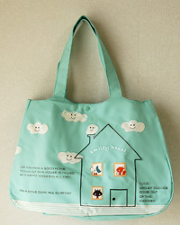 | GSJ_GS-055 | Picnic Bag_Smile | 0.20 | GSJ | 2,940YEN
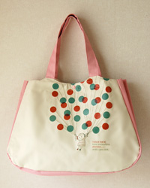 | GSJ_GS-051 | Picnic Bag_Flying | 0.20 | GSJ | 2,940YEN
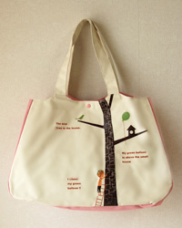 | GSJ_GS-049 | Picnic Bag_Balloon | 0.20 | GSJ | 2,940YEN
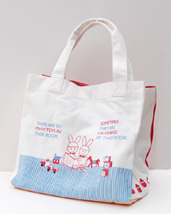 | ZEL_TR-MBAG | Mother's Bag Treasure Box_TR_Rabbits | 0.40 | ZEL | 3,360YEN  (149)  (90) | 200-280
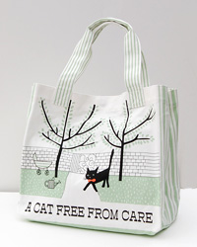 | ZEL_CA-MBAG | Mother's Bag Treasure Box_CA_Cat | 0.40 | ZEL | 3,360YEN

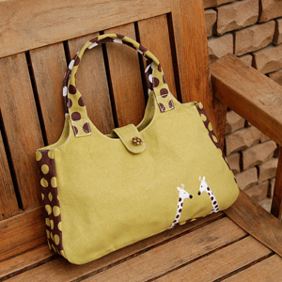 | SER_RT2-29 | Round Bag_couple | 0.26 | SER | 3,990YEN  (176)  (106) | 180-240
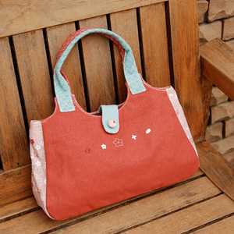 | SER_RT2-23 | Round Bag_horohoro | 0.26 | SER | 3,990YEN
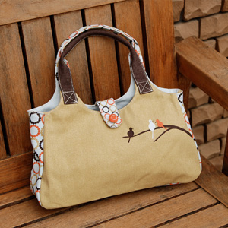 | SER_RT2-24 | Round Bag_roost | 0.26 | SER | 3,990YEN
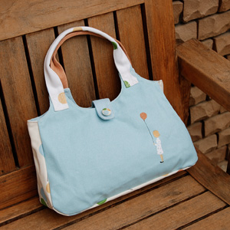 | SER_RT2-30 | Round Bag_to the sky | 0.26 | SER | 3,990YEN

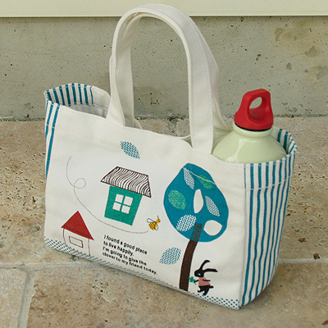 | YAN_sk-931 | Lunch Bag_Hutte | 0.15 | YAN | 1,575YEN  (70)  (42) | 100-180
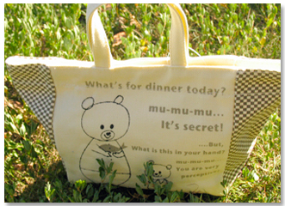 | ANN_71413 | Lunch Bag_forest hop | 0.15 | ANN | 1,575YEN
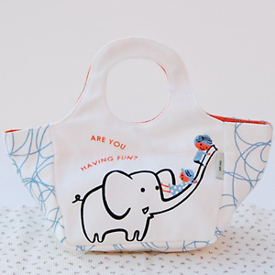 | ANN_71422 | Lunch Bag_chute | 0.15 | ANN | 1,890YEN  (84)  (50)
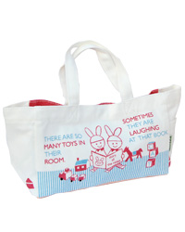 | ZEL_TR-LUNBA | Lunch Bag Treasure Box_TR_Rabbits | 0.15 | ZEL | 1,785YEN  (79)  (48)
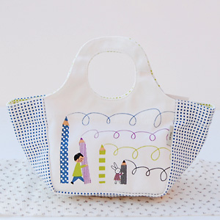 | ANN_71423 | Lunch Bag_scrawl | 0.15 | ANN | 1,890YEN

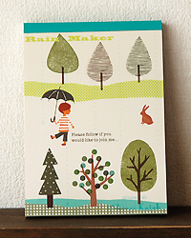 | GSJ_GS-019 | Memopad_Rain | 0.13 | GSJ | 399YEN  (18)  (11) | 20-35
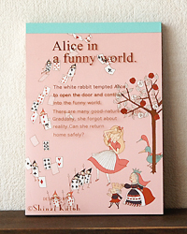 | GSJ_GS-013 | Memopad_Alice | 0.13 | GSJ | 399YEN
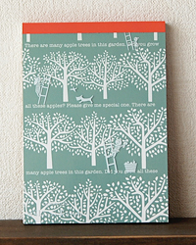 | GSJ_GS-014 | Memopad_Apple Garden | 0.13 | GSJ | 399YEN
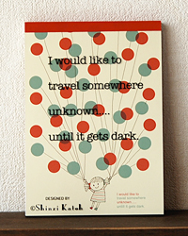 | GSJ_GS-017 | Memopad_Flying | 0.13 | GSJ | 399YEN
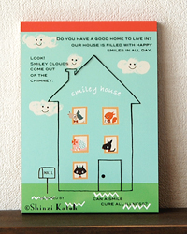 | GSJ_GS-021 | Memopad_Smile | 0.13 | GSJ | 399YEN
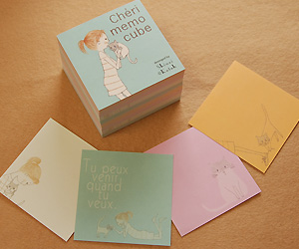 | SER_BL1-02 | Memo Cube Cheri | 0.31 | SER | 840YEN  (37)  (22) | 25-40
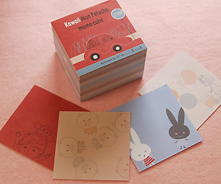 | SER_BL1-01 | Memo Cube Mon Peluche | 0.31 | SER | 840YEN
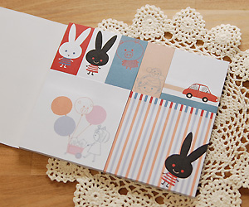 | SER_PO1-01 | Index Seal Mon Peluche | 0.09 | SER | 840YEN
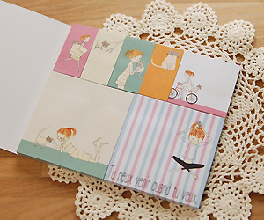 | SER_PO1-02 | Index Seal Cheri | 0.09 | SER | 840YEN
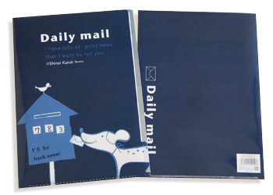 | SER_CF1-10 | ClearFile(single)_daily mail | 0.03 | SER | 262YEN 189YEN  (8.5)  (5) | 20-30
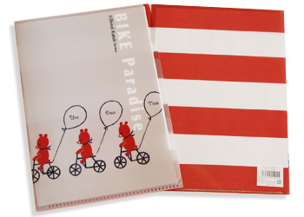 | SER_CF1-14 | ClearFile(single)_bike | 0.03 | SER | 262YEN 189YEN
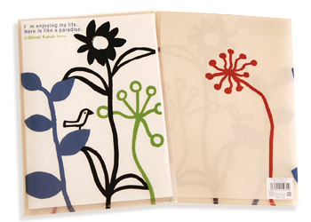 | SER_CF1-01 | ClearFile(single)_my life | 0.03 | SER | 262YEN 189YEN
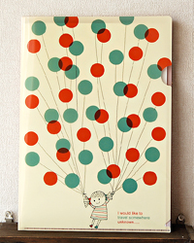 | GSJ_GS-006 | ClearFile(single)_Flying | 0.03 | GSJ | 262YEN  (11.5)  (7)
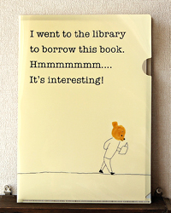 | GSJ_GS-004 | ClearFile(single)_Bear | 0.03 | GSJ | 262YEN
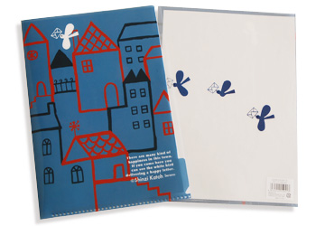 | SER_CF1-11 | ClearFile(single)_mail bird | 0.03 | SER | 262YEN 189YEN
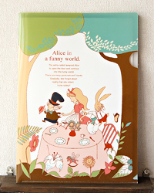 | GSJ_GS-011 | ClearFile(single)_Tea Party | 0.03 | GSJ | 262YEN
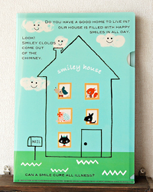 | GSJ_GS-010 | ClearFile(single)_Smile | 0.03 | GSJ | 262YEN

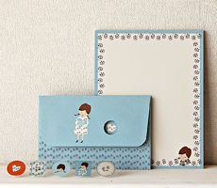 | GSJ_GS-031 | Letter set_Girl's Hea-rt | 0.09 | GSJ | 609YEN  (27)  (16) | 25-45
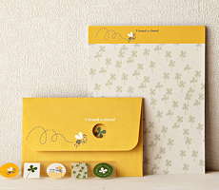 | GSJ_GS-032 | Letter set_Hacchi | 0.09 | GSJ | 609YEN
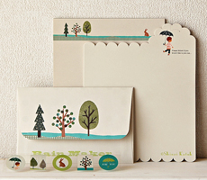 | GSJ_GS-026 | Letter set_Rain | 0.09 | GSJ | 609YEN
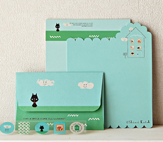 | GSJ_GS-028 | Letter set_Smile | 0.09 | GSJ | 609YEN
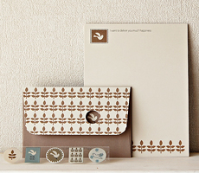 | GSJ_GS-033 | Letter set_White Birds | 0.09 | GSJ | 609YEN

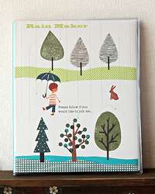 | GSJ_GS-038 | Album_Rain | 0.35 | GSJ | 1,365YEN  (60)  (36) | 60-90
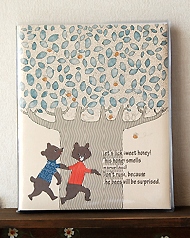 | GSJ_GS-044 | Album_Honey Tree | 0.35 | GSJ | 1,365YEN
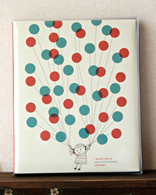 | GSJ_GS-036 | Album_Flying | 0.35 | GSJ | 1,365YEN
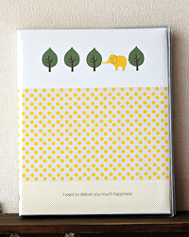 | GSJ_GS-043 | Album_Zousan | 0.35 | GSJ | 1,365YEN

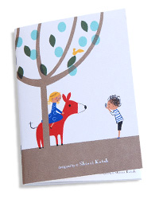 | CHA_SK-NTM-02 | Note Book(M)_Forest | 0.12 | CHA | 441YEN  (20)  (12) | 20-35
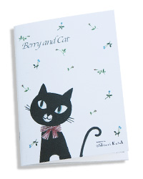 | CHA_SK-NTM-05 | Note Book(M)_Berry and Cat | 0.12 | CHA | 441YEN
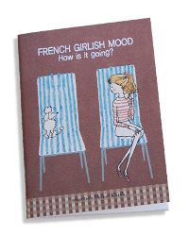 | CHA_SK-NTM-08 | Note Book(M)_French girlish mood[on chair] | 0.12 | CHA | 441YEN
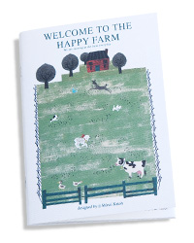 | CHA_SK-NTM-03 | Note Book(M)_Happy Farm | 0.12 | CHA | 441YEN
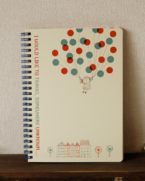 | GSJ_GS-057 | Ring Note A5 Flying | 0.23 | GSJ | 892YEN  (40)  (24) | 30-60
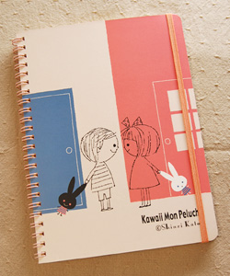 | SER_NA5-02 | Ring Note A5 Mon Peluche neighbors | 0.23 | SER | 1,050YEN 497YEN  (22)  (14)
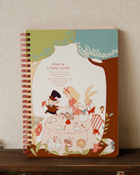 | GSJ_GS-058 | Ring Note A5 Tea Party | 0.23 | GSJ | 892YEN
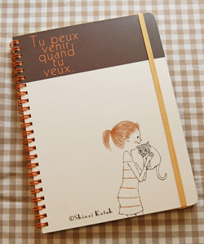 | SER_NA5-04 | Ring Note A5 Cheri hold | 0.23 | SER | 1,050YEN 497YEN
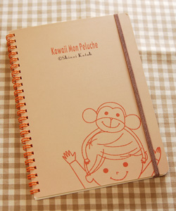 | SER_NA5-01 | Ring Note A5 Mon Peluche Mont | 0.23 | SER | 1,050YEN 497YEN
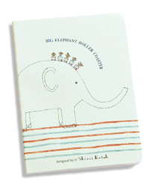 | CHA_SK-NTS-08 | Note Book(S)_Elephant | 0.03 | CHA | 336YEN  (15)  (9) | 18-25
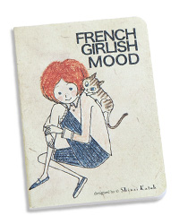 | CHA_SK-NTS-11 | Note Book(S)_French girlish mood[Blue pants] | 0.03 | CHA | 336YEN
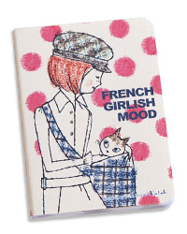 | CHA_SK-NTS-12 | Note Book(S)_French girlish mood[Pink dots] | 0.03 | CHA | 336YEN
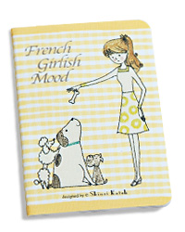 | CHA_SK-NTS-16 | Note Book(S)_French girlish mood[with three dogs-Yellow] | 0.03 | CHA | 336YEN
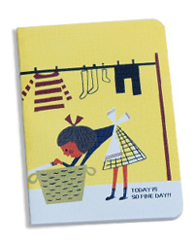 | CHA_SK-NTS-01 | Note Book(S)_So find day | 0.03 | CHA | 336YEN
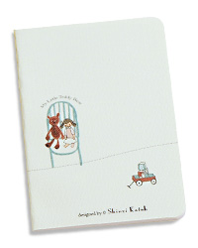 | CHA_SK-NTS-09 | Note Book(S)_Teddy bear | 0.03 | CHA | 336YEN
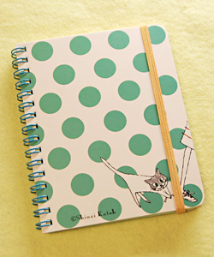 | SER_NM1-04 | Ring Note Memo Cheri mischief | 0.10 | SER | 840YEN 399YEN  (18)  (11) | 20-28
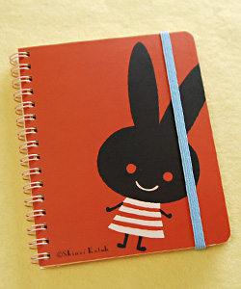 | SER_NM1-02 | Ring Note Memo Mon Peluche Jiji | 0.10 | SER | 840YEN 399YEN
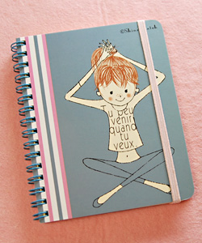 | SER_NM1-03 | Ring Note Memo Cheri relax | 0.10 | SER | 840YEN 399YEN

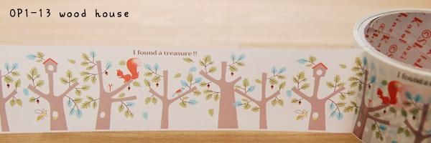 | SER_OP1-13 | OppTape_wood house | 0.06 | SER | 420YEN  (18.5)  (11) | 25-35
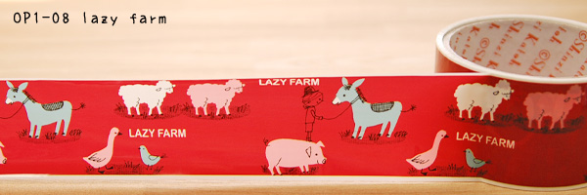 | SER_OP1-08 | OppTape_lazy farm | 0.06 | SER | 420YEN
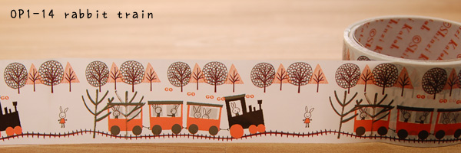 | SER_OP1-14 | OppTape_rabbit train | 0.06 | SER | 420YEN
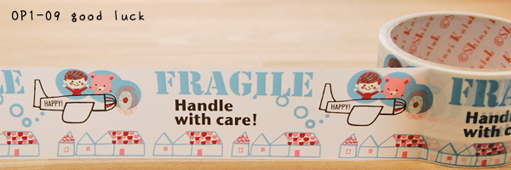 | SER_OP1-09 | OppTape_good luck | 0.06 | SER | 420YEN
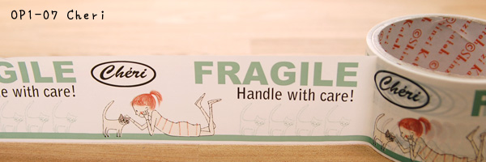 | SER_OP1-07 | OppTape_Cheri | 0.06 | SER | 420YEN
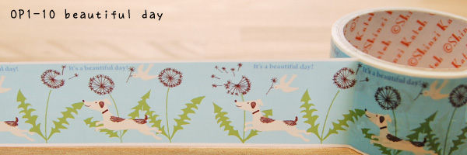 | SER_OP1-10 | OppTape_beautiful days | 0.06 | SER | 420YEN
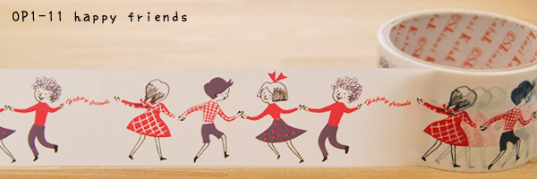 | SER_OP1-11 | OppTape_happy friends | 0.06 | SER | 420YEN
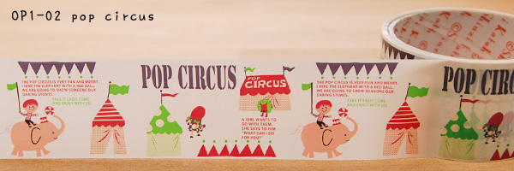 | SER_OP1-02 | OppTape_pop circus | 0.06 | SER | 420YEN

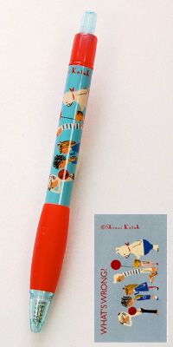 | SER_BPE1-20 | ballpen_what's wrong | 0.01 | SER | 294YEN  (13)  (8) | 12-22
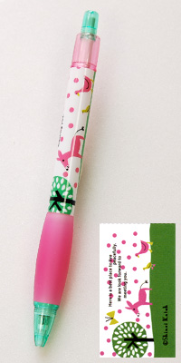 | SER_BPE1-19 | ballpen_village | 0.01 | SER | 294YEN
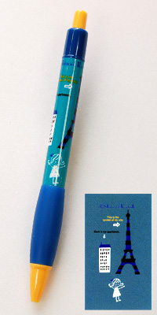 | SER_BPE1-14 | ballpen_paris | 0.01 | SER | 294YEN
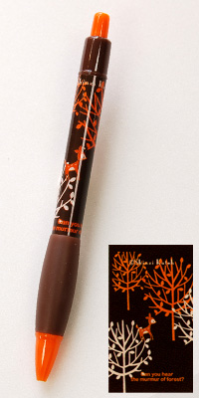 | SER_BPE1-13 | ballpen_murmur forest | 0.01 | SER | 294YEN

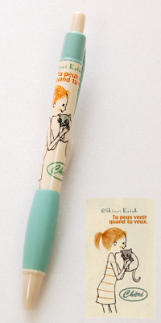 | SER_BPE1-10 | ballpen Cheri_kiss | 0.01 | SER | 294YEN

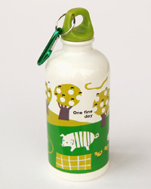 | ANN_71179 | Aluminum bottle(M)_apple tree farm | 0.16 | ANN | 1,260YEN  (56)  (34) | 60-90
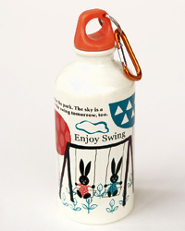 | ANN_71181 | Aluminum bottle(M)_branko | 0.16 | ANN | 1,260YEN
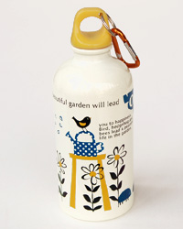 | ANN_71178 | Aluminum bottle(M)_good afternoon | 0.16 | ANN | 1,260YEN
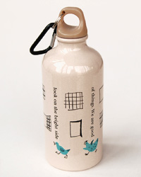 | ANN_71183 | Aluminum bottle(M)_optimistic | 0.16 | ANN | 1,260YEN
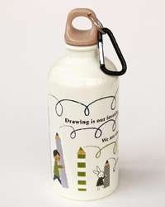 | ANN_71180 | Aluminum bottle(M)_scrawl | 0.16 | ANN | 1,260YEN
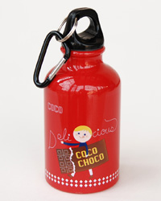 | ANN_71169 | Aluminum bottle(S)_coco | 0.11 | ANN | 1,050YEN  (46)  (28) | 50-80
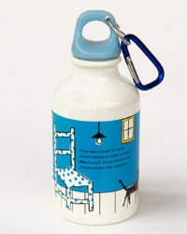 | ANN_71172 | Aluminum bottle(S)_comfortable | 0.11 | ANN | 1,050YEN
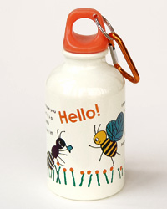 | ANN_71175 | Aluminum bottle(S)_hello! | 0.11 | ANN | 1,050YEN
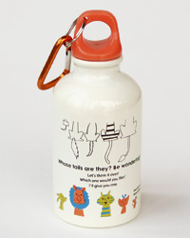 | ANN_71168 | Aluminum bottle(S)_tails | 0.11 | ANN | 1,050YEN
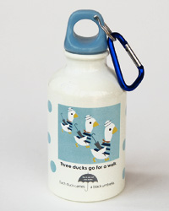 | ANN_71167 | Aluminum bottle(S)_three ducks | 0.11 | ANN | 1,050YEN
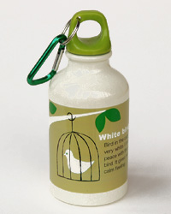 | ANN_71171 | Aluminum bottle(S)_white bird | 0.11 | ANN | 1,050YEN
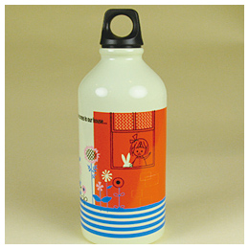 | SER_SAB1-04 | Trekking Bottle(M) MonPeluche_garden | 0.15 | SER | 1,680YEN 1,260YEN
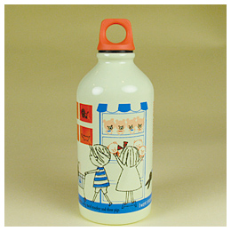 | SER_SAB1-03 | Trekking Bottle(M) MonPeluche_Shopping | 0.15 | SER | 1,680YEN 1,260YEN
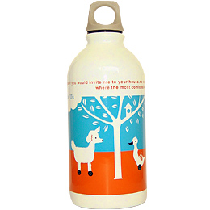 | SER_AB1-27 | Trekking Bottle(M)_Animal | 0.15 | SER | 1,680YEN 1,260YEN
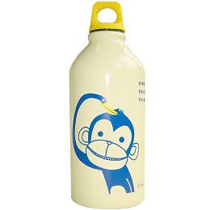 | SER_AB2-50 | Trekking Bottle(M)_Gibbon | 0.15 | SER | 1,680YEN 1,260YEN
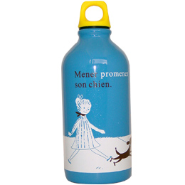 | SER_AB1-16 | Trekking Bottle(M)_Girl&Dog | 0.15 | SER | 1,680YEN 1,260YEN
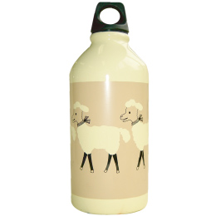 | SER_AB2-48 | Trekking Bottle(M)_sheep | 0.15 | SER | 1,680YEN 1,260YEN
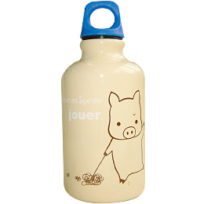 | SER_AB2-43 | Trekking Bottle(S)_a pig | 0.10 | SER | 1,470YEN 976YEN  (43)  (26) | 50-80
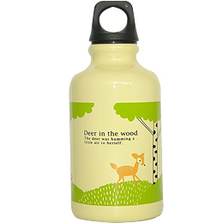 | SER_AB1-01 | Trekking Bottle(S)_Bambi | 0.10 | SER | 1,470YEN 976YEN
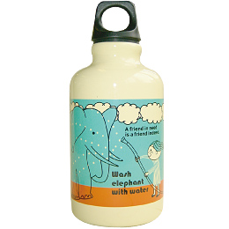 | SER_AB2-41 | Trekking Bottle(S)_bathing | 0.10 | SER | 1,470YEN 976YEN
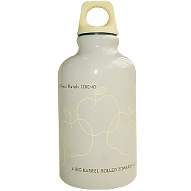 | SER_AB2-34 | Trekking Bottle(S)_many apples | 0.10 | SER | 1,470YEN 976YEN
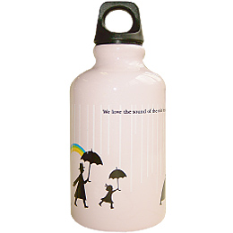 | SER_AB2-31 | Trekking Bottle(S)_rain | 0.10 | SER | 1,470YEN 976YEN
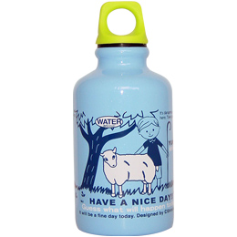 | SER_AB1-02 | Trekking Bottle(S)_Sheep | 0.10 | SER | 1,470YEN 976YEN
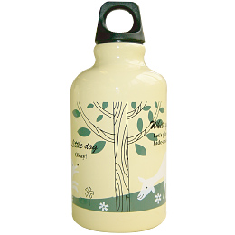 | SER_AB2-45 | Trekking Bottle(S)_under the tree | 0.10 | SER | 1,470YEN 976YEN
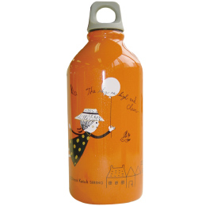 | SER_AB2-46 | Trekking Bottle(M)_in the sky | 0.15 | SER | 1,680YEN 1,260YEN
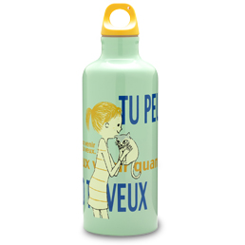 | SER_SDS4-02 | Cold Trekking Bottle(M) Cheri_Cheri | 0.30 | SER | 3,465YEN  (154)  (93) | 90-120
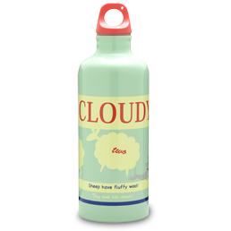 | SER_DS2-39 | Cold Trekking Bottle(M)_cloudy | 0.30 | SER | 3,465YEN
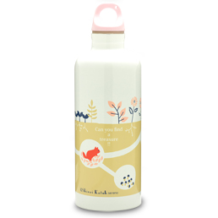 | SER_DS2-34 | Cold Trekking Bottle(M)_in the ground | 0.30 | SER | 3,465YEN
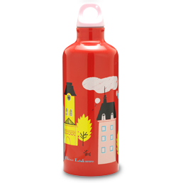 | SER_DS2-32 | Cold Trekking Bottle(M)_paris | 0.30 | SER | 3,465YEN
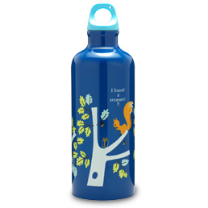 | SER_DS2-35 | Cold Trekking Bottle(M)_wood house | 0.30 | SER | 3,465YEN

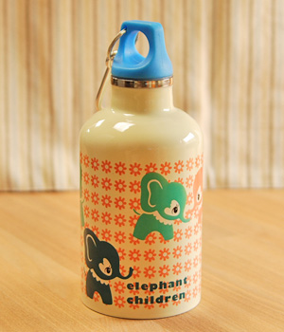 | ANN_71255 | Cold Trekking Bottle(280ml)_elephant children | 0.25 | ANN | 2,940YEN  (130)  (78) | 50-80
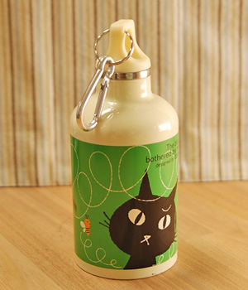 | ANN_71254 | Cold Trekking Bottle(280ml)_bunbun | 0.25 | ANN | 2,940YEN
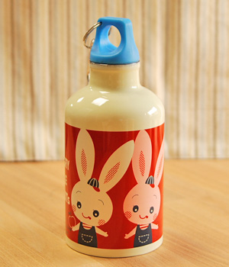 | ANN_71257 | Cold Trekking Bottle(280ml)_harapeko | 0.25 | ANN | 2,940YEN
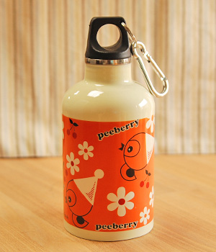 | ANN_71256 | Cold Trekking Bottle(280ml)_peeberry | 0.25 | ANN | 2,940YEN
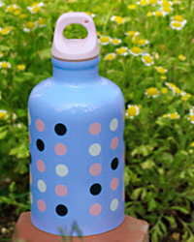 | SER_DS1-13 | Cold Trekking Bottle(S)_cell | 0.25 | SER | 2,940YEN
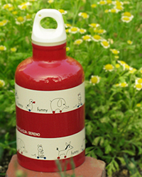 | SER_DS1-06 | Cold Trekking Bottle(S)_funny | 0.25 | SER | 2,940YEN
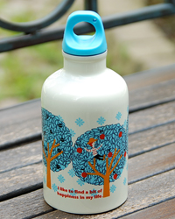 | SER_DS2-27 | Cold Trekking Bottle(S)_happy tree | 0.25 | SER | 2,940YEN
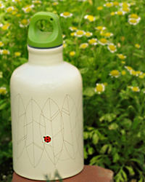 | SER_DS1-11 | Cold Trekking Bottle(S)_lady bird | 0.25 | SER | 2,940YEN
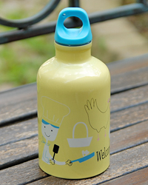 | SER_DS2-26 | Cold Trekking Bottle(S)_mart | 0.25 | SER | 2,940YEN
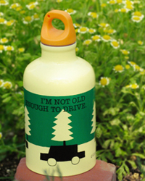 | SER_DS1-01 | Cold Trekking Bottle(S)_Slow drive | 0.25 | SER | 2,940YEN
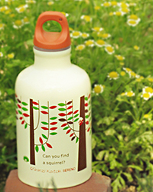 | SER_DS1-18 | Cold Trekking Bottle(S)_squirrel | 0.25 | SER | 2,940YEN
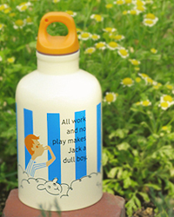 | SER_DS1-02 | Cold Trekking Bottle(S)_whistle | 0.25 | SER | 2,940YEN
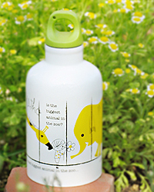 | SER_DS1-20 | Cold Trekking Bottle(S)_zoo | 0.25 | SER | 2,940YEN
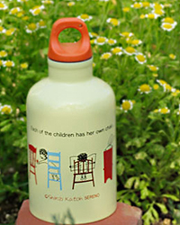 | SER_DS1-14 | Cold Trekking Bottle(S)_chair | 0.25 | SER | 2,940YEN
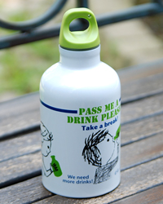 | SER_DS2-25 | Cold Trekking Bottle(S)_drink | 0.25 | SER | 2,940YEN

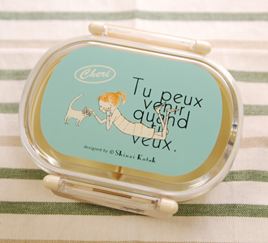 | SER_SLO2-05 | Single Lunch Box Cheri_lying | 0.20 | SER | 1,260YEN  (56)  (34) | 60-90
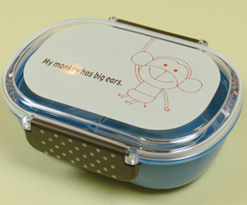 | SER_SLO1-03 | Single Lunch Box MonPeluche_Mont | 0.20 | SER | 1,260YEN
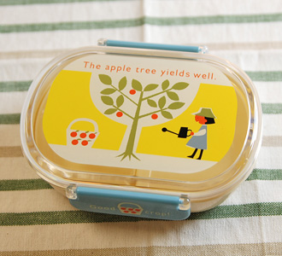 | SER_LO1-15 | Single Lunch Box_crop | 0.20 | SER | 1,260YEN
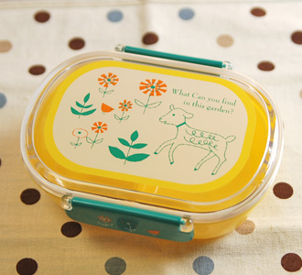 | SER_LO1-06 | Single Lunch Box_flower garden | 0.20 | SER | 1,260YEN
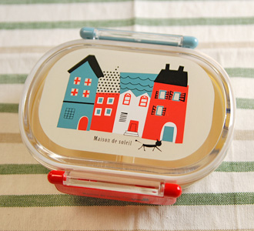 | SER_LO1-01 | Single Lunch Box_house | 0.20 | SER | 1,260YEN
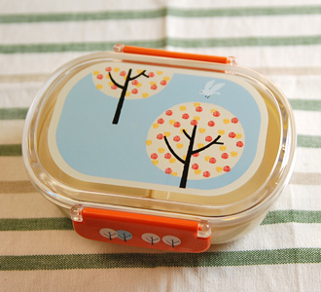 | SER_LO1-09 | Single Lunch Box_perch | 0.20 | SER | 1,260YEN
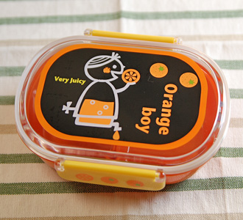 | SER_LO1-05 | Single Lunch Box_Orange boy | 0.20 | SER | 1,260YEN
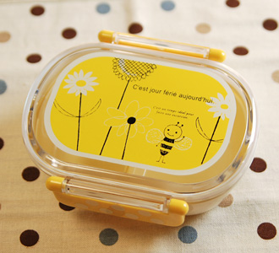 | SER_LO1-14 | Single Lunch Box_fleur | 0.20 | SER | 1,260YEN
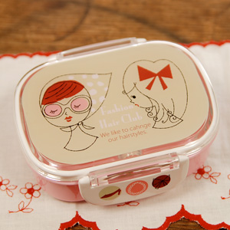 | SER_LO2-30 | Single Lunch Box Fashion hair | 0.20 | SER | 1,470YEN  (65)  (39) | 90-120
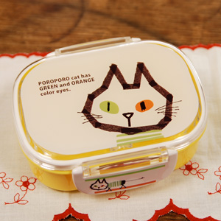 | SER_LO2-27 | Single Lunch Box Green&Orange | 0.20 | SER | 1,470YEN
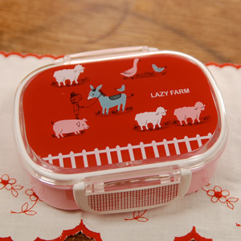 | SER_LO2-25 | Single Lunch Box Lazzy farm | 0.20 | SER | 1,470YEN
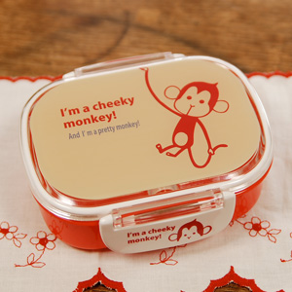 | SER_LO2-28 | Single Lunch Box Red monkey | 0.20 | SER | 1,470YEN
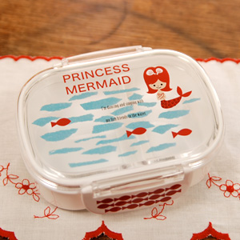 | SER_LO2-18 | Single Lunch Box Mermaid | 0.20 | SER | 1,470YEN
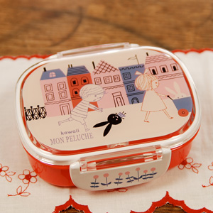 | SER_SLO3-06 | Single Lunch Box Mon Peluche town | 0.20 | SER | 1,470YEN
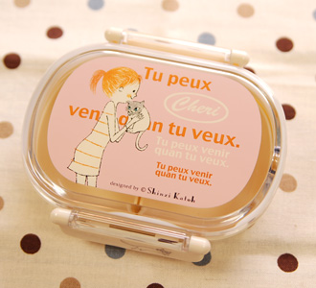 | SER_SLO2-04 | Single Lunch Box Cheri_cuddle | 0.20 | SER | 1,260YEN

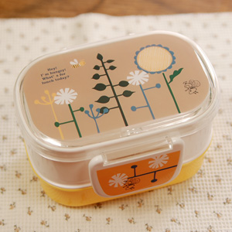 | SER_LD2-17 | W-decks Lunch Box Hungry bee | 0.23 | SER | 1,680YEN  (74)  (43) | 80-120
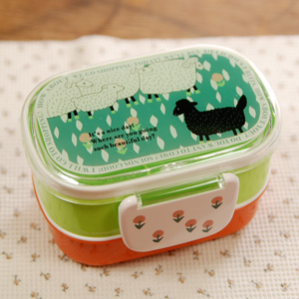 | SER_LD2-18 | W-decks Lunch Box Nice day | 0.23 | SER | 1,680YEN
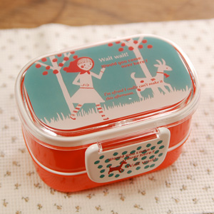 | SER_LD2-21 | W-decks Lunch Box Wait | 0.23 | SER | 1,680YEN
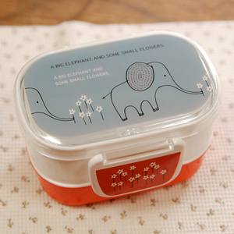 | SER_LD2-19 | W-decks Lunch Box Pick | 0.23 | SER | 1,680YEN
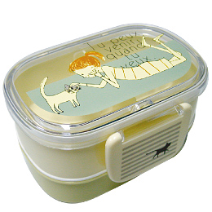 | SER_LD1-14 | W-decks Lunch Box Cheri_Cheri | 0.23 | SER | 1,470YEN  (65)  (39) | 90-120
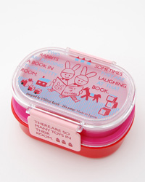 | ZEL_TR-LBOX | W-decks Lunch Box Treasure Box_TR_Rabbits | 0.20 | ZEL | 1,365YEN
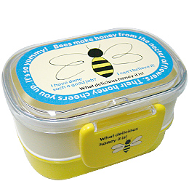 | SER_LD1-07 | W-decks Lunch Box_Big Bee | 0.23 | SER | 1,470YEN
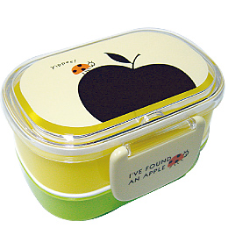 | SER_LD1-05 | W-decks Lunch Box_Black Apple | 0.23 | SER | 1,470YEN
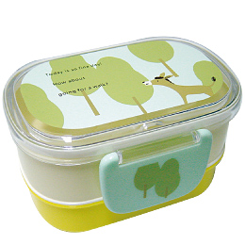 | SER_LD1-15 | W-decks Lunch Box_Donkey | 0.23 | SER | 1,470YEN
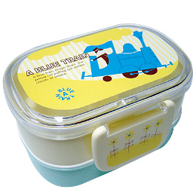 | SER_LD1-04 | W-decks Lunch Box_Blue Train | 0.23 | SER | 1,470YEN
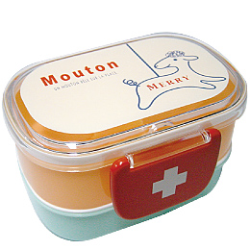 | SER_LD1-06 | W-decks Lunch Box_Merry | 0.23 | SER | 1,470YEN
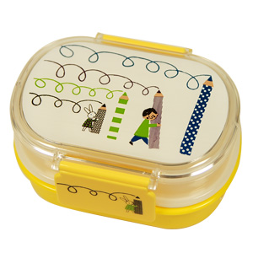 | ANN_76021 | W-decks Lunch Box_scrawl | 0.23 | ANN | 1,575YEN
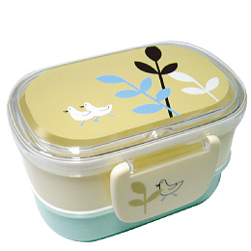 | SER_LD1-11 | W-decks Lunch Box_Two Birds | 0.23 | SER | 1,470YEN
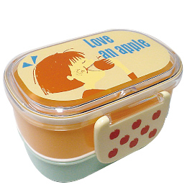 | SER_LD1-13 | W-decks Lunch Box_Love an Apple | 0.23 | SER | 1,470YEN

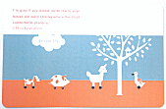 | SER_PM1-14 | Place Mat_Animal | 0.06 | SER | 525YEN  (23)  (14) | 20-35
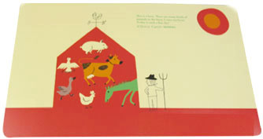 | SER_PM2-40 | Place Mat_barn | 0.06 | SER | 525YEN
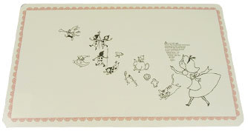 | SER_PM2-30 | Place Mat_alice | 0.06 | SER | 525YEN
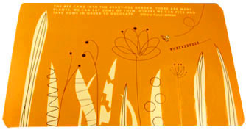 | SER_PM2-26 | Place Mat_bee | 0.06 | SER | 525YEN
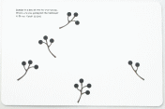 | SER_PM1-04 | Place Mat_Berries | 0.06 | SER | 525YEN
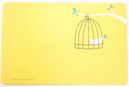 | SER_PM1-05 | Place Mat_Cage | 0.06 | SER | 525YEN
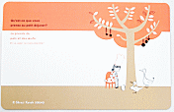 | SER_PM1-15 | Place Mat_Cook | 0.06 | SER | 525YEN
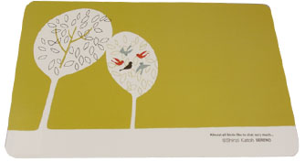 | SER_PM2-39 | Place Mat_chat | 0.06 | SER | 525YEN
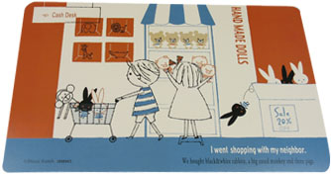 | SER_SPM1-02 | Place Mat Mon Peluche_shopping | 0.06 | SER | 525YEN
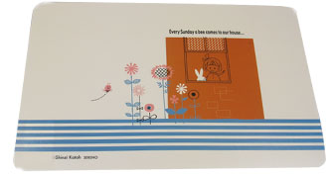 | SER_SPM1-04 | Place Mat Mon Peluche_garden | 0.06 | SER | 525YEN
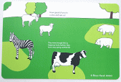 | SER_PM1-13 | Place Mat_Farmyard | 0.06 | SER | 525YEN
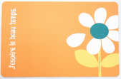 | SER_PM1-01 | Place Mat_Flower | 0.06 | SER | 525YEN
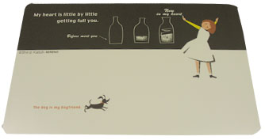 | SER_PM2-34 | Place Mat_girl | 0.06 | SER | 525YEN
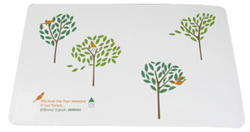 | SER_PM2-22 | Place Mat_four seasons | 0.06 | SER | 525YEN

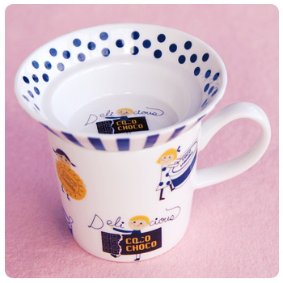 | ANN_71311 | due mug_coco | 0.44 | ANN | 1,365YEN  (60)  (36) | 45-70
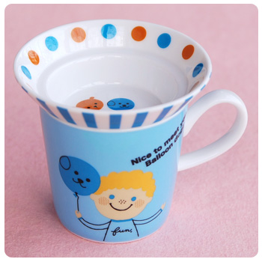 | ANN_71314 | due mug_balloon dog | 0.44 | ANN | 1,365YEN
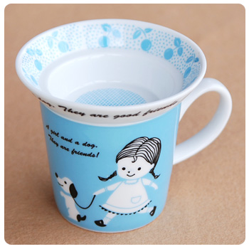 | ANN_71319 | due mug_friends | 0.44 | ANN | 1,365YEN

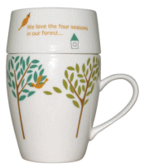 | MAR_CM2008 | CafeMug Colorful_bird tree | 0.40 | MAR | 1,260YEN  (56)  (34) | 45-70
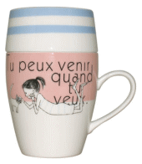 | MAR_CM2001 | CafeMug Colorful_cheri | 0.40 | MAR | 1,260YEN
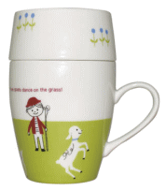 | MAR_CM2009 | CafeMug Colorful_dance | 0.40 | MAR | 1,260YEN
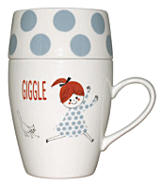 | MAR_CM2004 | CafeMug Colorful_giggle | 0.40 | MAR | 1,260YEN
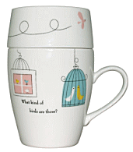 | MAR_CM2000 | CafeMug Colorful_song | 0.40 | MAR | 1,260YEN
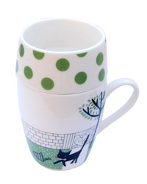 | ZEL_CA-MUG | Mug Cup Treasure Box_CA_Cat | 0.40 | ZEL | 1,365YEN
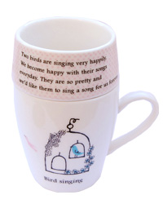 | ZEL_TB-MUG | Mug Cup Treasure Box_TB_Birds | 0.40 | ZEL | 1,365YEN

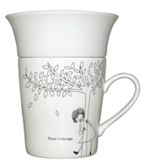 | MAR_CM1900 | CafeMug Monotone_Under The Tree | 0.40 | MAR | 1,260YEN
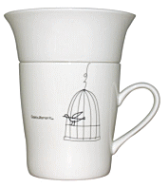 | MAR_CM1901 | CafeMug Monotone_bird cage | 0.40 | MAR | 1,260YEN
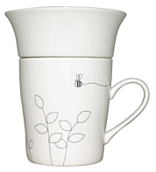 | MAR_CM1912 | CafeMug Monotone_bee | 0.40 | MAR | 1,260YEN
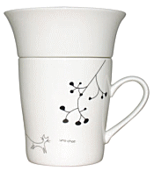 | MAR_CM1909 | CafeMug Monotone_berry and cat | 0.40 | MAR | 1,260YEN

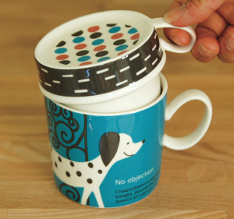 | MAR_CM2401 | Cafemug Upside-down dog | 0.05 | MAR | 1,890YEN  (84)  (50) | 60-90
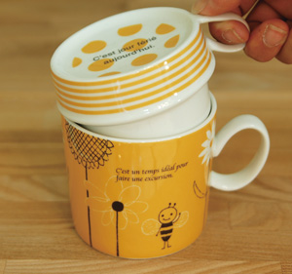 | MAR_CM2406 | Cafemug Upside-down fluer | 0.05 | MAR | 1,890YEN
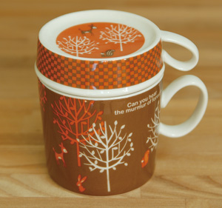 | MAR_CM2408 | Cafemug Upside-down murmur | 0.05 | MAR | 1,890YEN
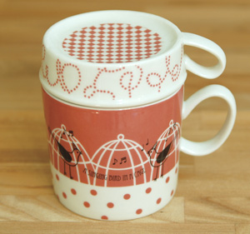 | MAR_CM2414 | Cafemug Upside-down tone | 0.05 | MAR | 1,890YEN
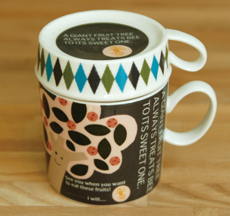 | MAR_CM2412 | Cafemug Upside-down tree and bee | 0.05 | MAR | 1,890YEN
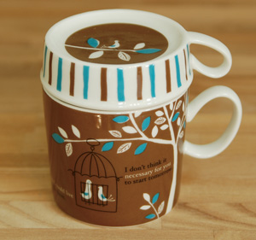 | MAR_CM2404 | Cafemug Upside-down under the tree | 0.05 | MAR | 1,890YEN
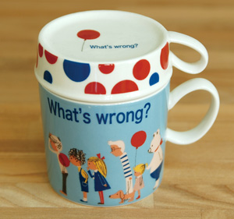 | MAR_CM2405 | Cafemug Upside-down whats wrong | 0.05 | MAR | 1,890YEN

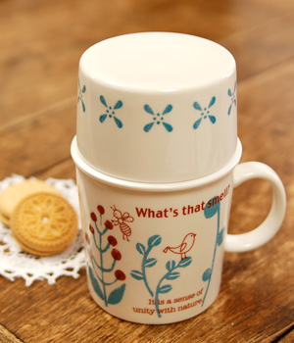 | YAN_SK214 | Tea Mug Set Bontanical | 0.50 | YAN | 1,575YEN  (70)  (42) | 60-90
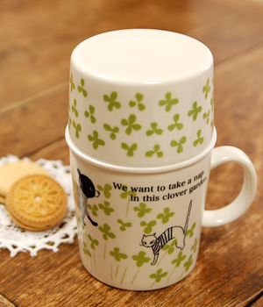 | YAN_SK213 | Tea Mug Set Clover | 0.50 | YAN | 1,575YEN
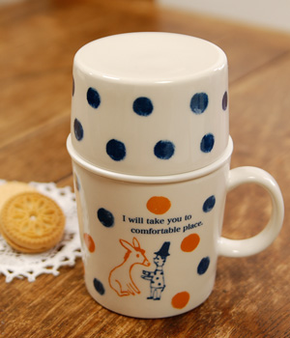 | YAN_SK215 | Tea Mug Set Donkey | 0.50 | YAN | 1,575YEN
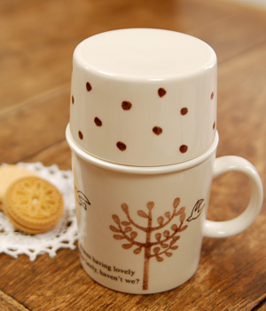 | YAN_SK210 | Tea Mug Set Forest | 0.50 | YAN | 1,575YEN
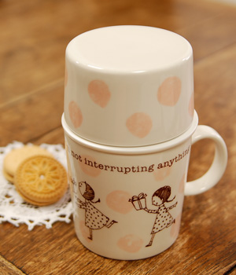 | YAN_SK211 | Tea Mug Set Present | 0.50 | YAN | 1,575YEN
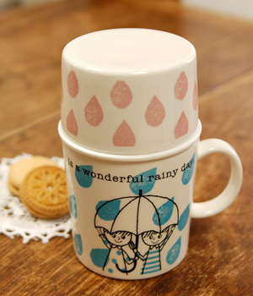 | YAN_SK212 | Tea Mug Set Rainy | 0.50 | YAN | 1,575YEN

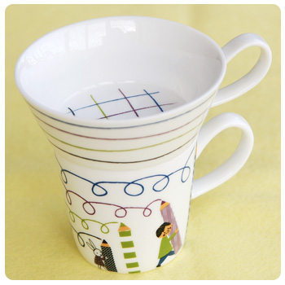 | ANN_71326 | deux mug_scrawl | 0.55 | ANN | 1,575YEN  (70)  (40) | 45-70
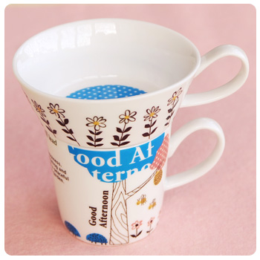 | ANN_71329 | deux mug_good afternoon | 0.55 | ANN | 1,575YEN
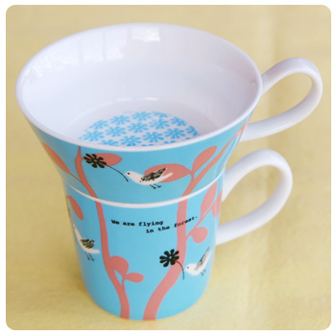 | ANN_71325 | deux mug_forest | 0.55 | ANN | 1,575YEN
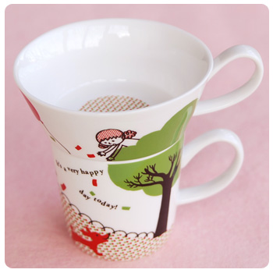 | ANN_71324 | deux mug_above | 0.55 | ANN | 1,575YEN

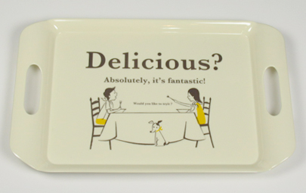 | SER_MT1-14 | Serving Tray_delicious | 0.62 | SER | 2,625YEN 1,890YEN  (85)  (50) | 60-90
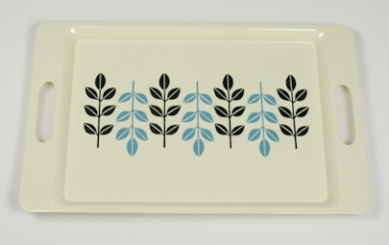 | SER_MT2-19 | Serving Tray_eternal | 0.62 | SER | 2,625YEN 1,890YEN
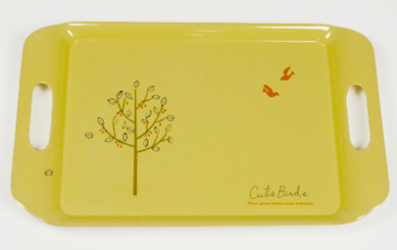 | SER_MT1-01 | Serving Tray_cute birds | 0.62 | SER | 2,625YEN 1,890YEN
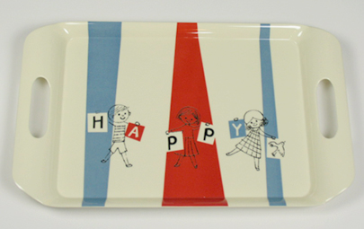 | SER_MT1-15 | Serving Tray_happy | 0.62 | SER | 2,625YEN 1,890YEN
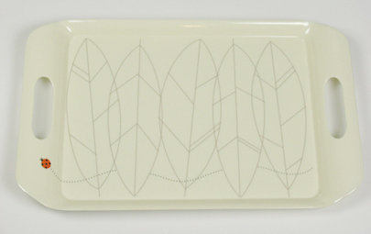 | SER_MT1-05 | Serving Tray_lady bird | 0.62 | SER | 2,625YEN 1,890YEN
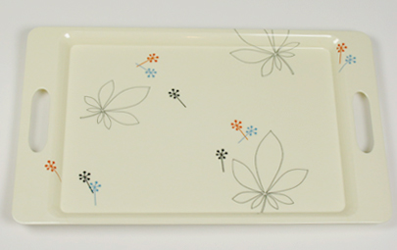 | SER_MT2-20 | Serving Tray_silent | 0.62 | SER | 2,625YEN 1,890YEN
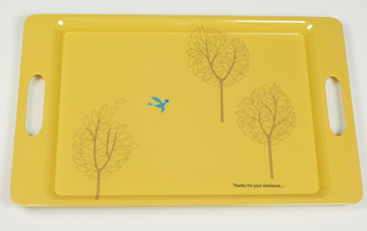 | SER_MT2-25 | Serving Tray_thanks | 0.62 | SER | 2,625YEN 1,890YEN
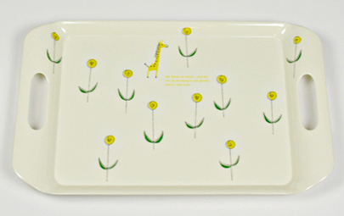 | SER_MT1-02 | Serving Tray_small garden | 0.62 | SER | 2,625YEN 1,890YEN
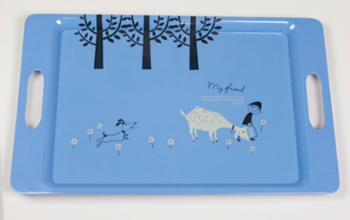 | SER_MT2-29 | Serving Tray_myfriend | 0.62 | SER | 2,625YEN 1,890YEN

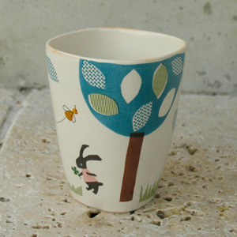 | YAN_SK-122 | Hutte_Cup | 0.20 | YAN | 840YEN  (37)  (22) | 35-50
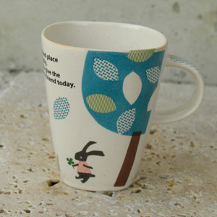 | YAN_SK-120 | Hutte_Mug | 0.20 | YAN | 1,050YEN  (46)  (28) | 40-50
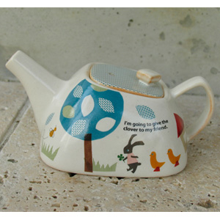 | YAN_SK-124 | Hutte_Pot | 0.50 | YAN | 2,940YEN  (130)  (80) | 120-150
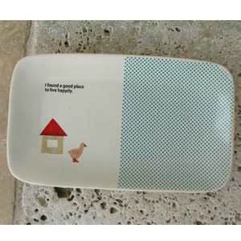 | YAN_SK-123 | Hutte_SQUAREPlate | 0.40 | YAN | 1,260YEN  (56)  (34) | 50-80

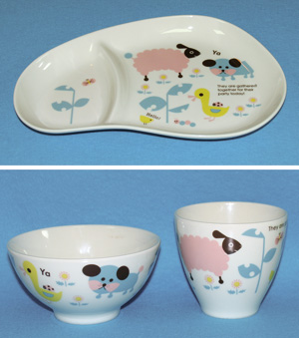 | YAN_SK-330 | Mon Enfant Party_SET | 0.75 | YAN | 3,150YEN  (140)  (84) | 110-140

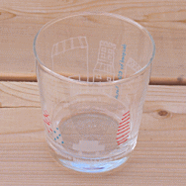 | SER_GW1-02 | Glass Cup Trip | 0.20 | SER | 525YEN  (23)  (14) | 15-22
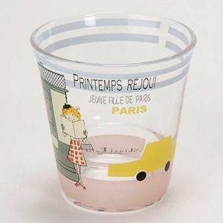 | SEK_882560 | Short Tumbler PRINTEMPS REJOUI_Voyage | 0.20 | SEK | 924YEN  (41)  (24) | 20-30
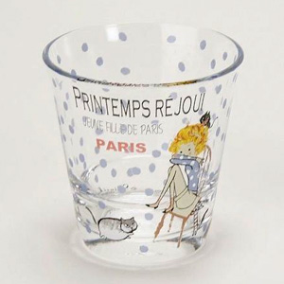 | SEK_882570 | Short Tumbler PRINTEMPS REJOUI_Room | 0.20 | SEK | 924YEN

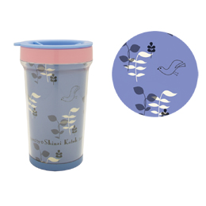 | SER_TBC1-13 | Tumbler280ml Bird's song | 0.20 | SER | 1,470YEN  (65)  (38) | 75-100
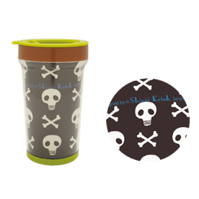 | SER_TBB1-08 | Tumbler280ml Bone | 0.20 | SER | 1,470YEN
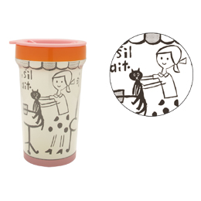 | SER_TBD1-22 | Tumbler280ml Cafe | 0.20 | SER | 1,470YEN
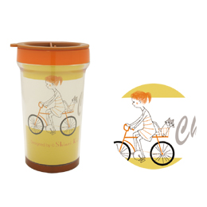 | SER_TBA1-02 | Tumbler280ml Cycling | 0.20 | SER | 1,470YEN
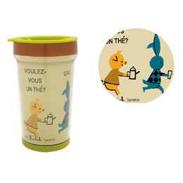 | SER_TBB1-09 | Tumbler280ml Delicieux | 0.20 | SER | 1,470YEN
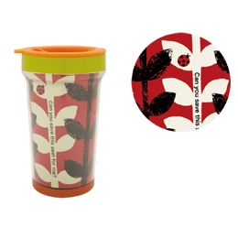 | SER_TBE1-26 | Tumbler280ml Ladybug | 0.20 | SER | 1,470YEN
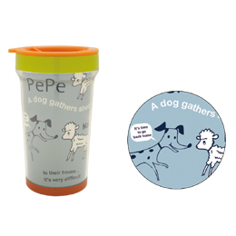 | SER_TBE1-27 | Tumbler280ml Pepe | 0.20 | SER | 1,470YEN
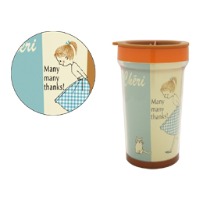 | SER_TBA1-06 | Tumbler280ml Thanks | 0.20 | SER | 1,470YEN
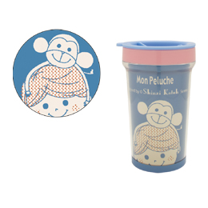 | SER_TBC1-17 | Tumbler280ml Mont | 0.20 | SER | 1,470YEN

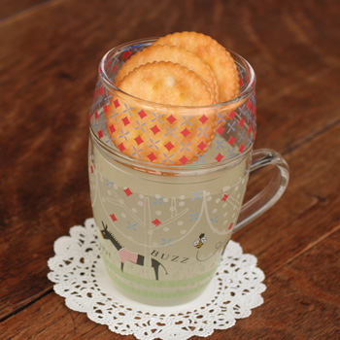 | ROY_RG-20030 | GlassCafeMugSet_dreamy | 0.20 | ROY | 1,470YEN  (65)  (38) | 40-60
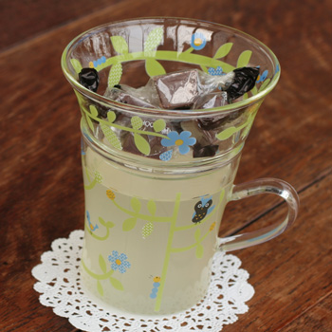 | ROY_RG-20026 | GlassCafeMugSet_green house | 0.20 | ROY | 1,470YEN
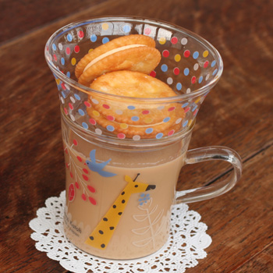 | ROY_RG-20023 | GlassCafeMugSet_kirin | 0.20 | ROY | 1,470YEN
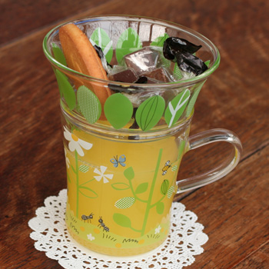 | ROY_RG-20022 | GlassCafeMugSet_small talk | 0.20 | ROY | 1,470YEN
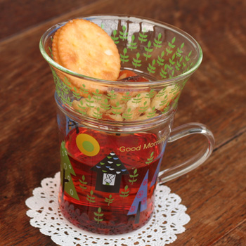 | ROY_RG-20025 | GlassCafeMugSet_wood | 0.20 | ROY | 1,470YEN
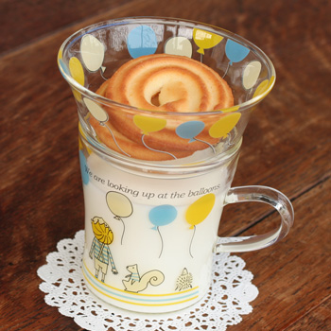 | ROY_RG-20024 | GlassCafeMugSet_balloons | 0.20 | ROY | 1,470YEN
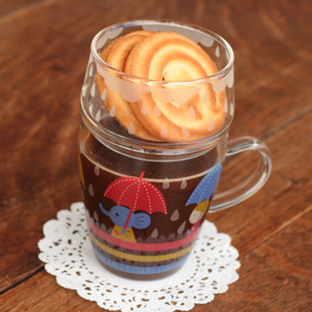 | ROY_RG-20031 | GlassCafeMugSet_umbrella | 0.20 | ROY | 1,470YEN

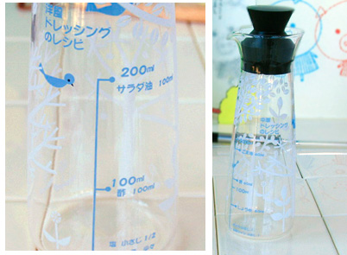 | ROY_RG-19780 | Dressing Bottle Petit Bois Western | 0.30 | ROY | 1,680YEN
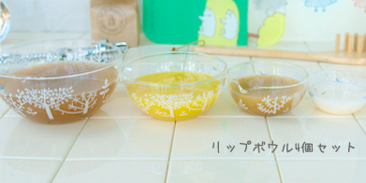 | ROY_RG-19742 | Petit Bois Lip Bowl 4set | 0.50 | ROY | 4,200YEN
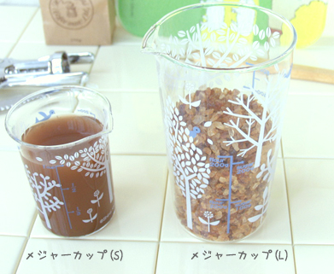 | ROY_RG-19762 | Petit Bois Measure Cup L | 0.30 | ROY | 1,260YEN
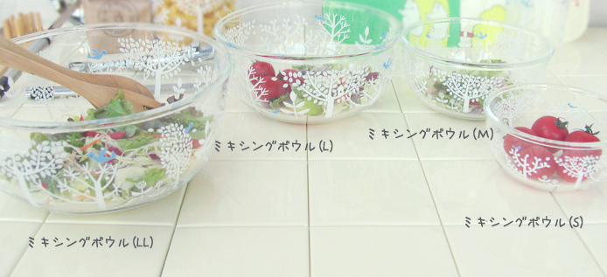 | ROY_RG-19750 | Petit Bois Mixing Bowl S | 0.42 | ROY | 1,050YEN
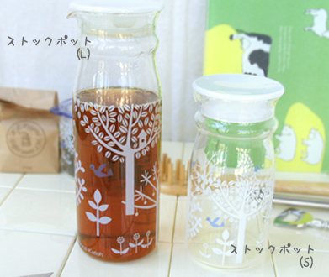 | ROY_RG-19703 | Petit Bois Stock Pot[S] | 0.30 | ROY | 1,155YEN
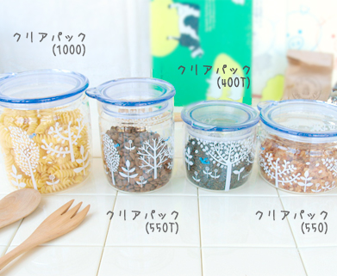 | ROY_RG-19712 | Petit Bois ClearPack1000 | 0.55 | ROY | 1,680YEN

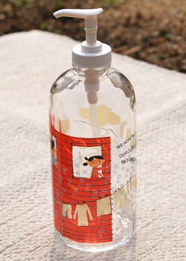 | ROY_RG-20154 | Lotion Bottle_laundry | 0.48 | ROY | 1,890YEN  (84)  (50) | 80-100
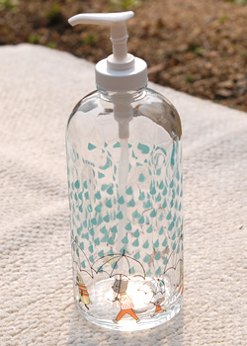 | ROY_RG-20156 | Lotion Bottle_rainy | 0.48 | ROY | 1,890YEN
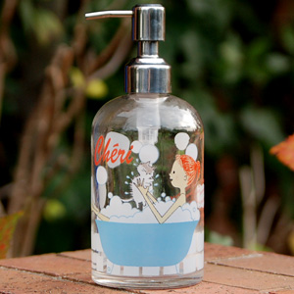 | SER_LB1-20 | ShampooBottle_cheri | 0.48 | SER | 2,100YEN  (93)  (55) | 80-100
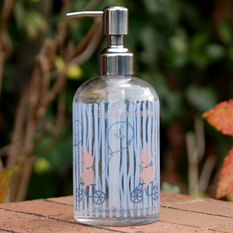 | SER_LB1-03 | ShampooBottle_quartet | 0.48 | SER | 2,100YEN
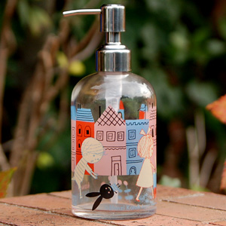 | SER_LB1-23 | ShampooBottle_mon peluche | 0.48 | SER | 2,100YEN
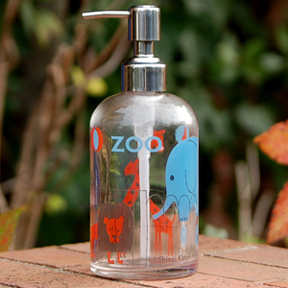 | SER_LB1-18 | ShampooBottle_holiday | 0.48 | SER | 2,100YEN

