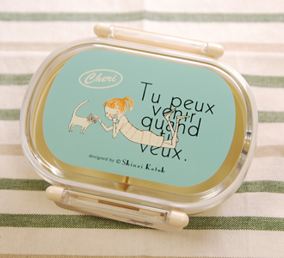 | SER_SLO2-05 | Single Lunch Box Cheri_lying | 0.20 | SER | 1,260YEN
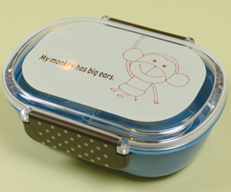 | SER_SLO1-03 | Single Lunch Box MonPeluche_Mont | 0.20 | SER | 1,260YEN
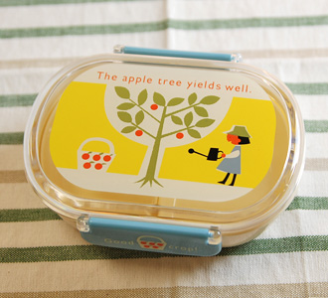 | SER_LO1-15 | Single Lunch Box_crop | 0.20 | SER | 1,260YEN
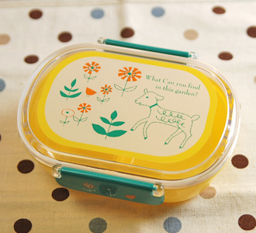 | SER_LO1-06 | Single Lunch Box_flower garden | 0.20 | SER | 1,260YEN
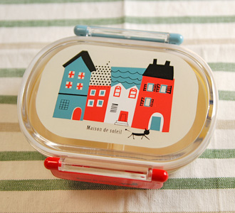 | SER_LO1-01 | Single Lunch Box_house | 0.20 | SER | 1,260YEN
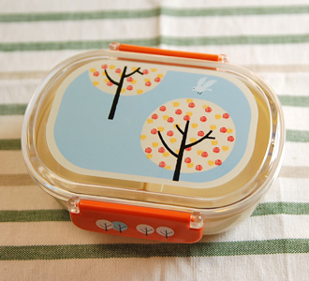 | SER_LO1-09 | Single Lunch Box_perch | 0.20 | SER | 1,260YEN
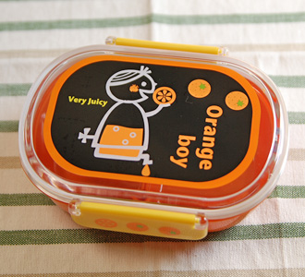 | SER_LO1-05 | Single Lunch Box_Orange boy | 0.20 | SER | 1,260YEN
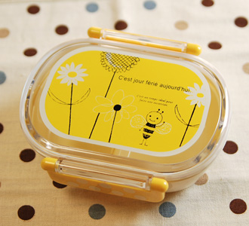 | SER_LO1-14 | Single Lunch Box_fleur | 0.20 | SER | 1,260YEN
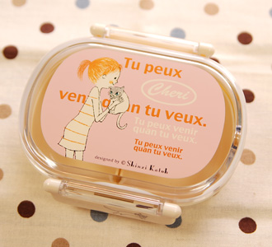 | SER_SLO2-04 | Single Lunch Box Cheri_cuddle | 0.20 | SER | 1,260YEN
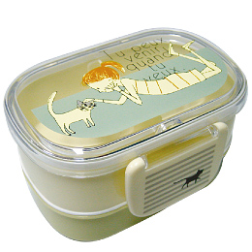 | SER_LD1-14 | W-decks Lunch Box Cheri_Cheri | 0.23 | SER | 1,470YEN
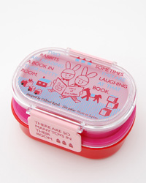 | ZEL_TR-LBOX | W-decks Lunch Box Treasure Box_TR_Rabbits | 0.20 | ZEL | 1,365YEN
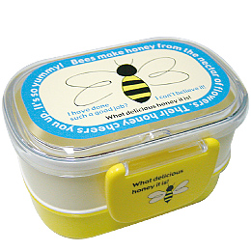 | SER_LD1-07 | W-decks Lunch Box_Big Bee | 0.23 | SER | 1,470YEN
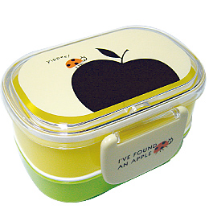 | SER_LD1-05 | W-decks Lunch Box_Black Apple | 0.23 | SER | 1,470YEN
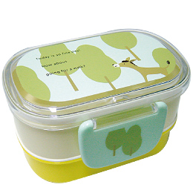 | SER_LD1-15 | W-decks Lunch Box_Donkey | 0.23 | SER | 1,470YEN
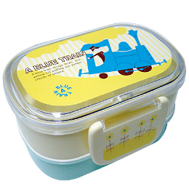 | SER_LD1-04 | W-decks Lunch Box_Blue Train | 0.23 | SER | 1,470YEN
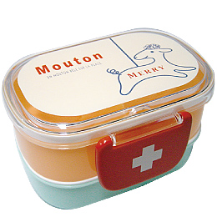 | SER_LD1-06 | W-decks Lunch Box_Merry | 0.23 | SER | 1,470YEN
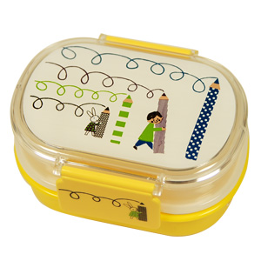 | ANN_76021 | W-decks Lunch Box_scrawl | 0.23 | ANN | 1,575YEN
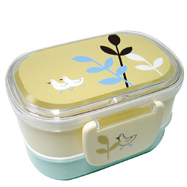 | SER_LD1-11 | W-decks Lunch Box_Two Birds | 0.23 | SER | 1,470YEN
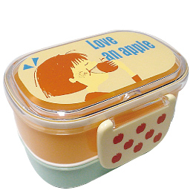 | SER_LD1-13 | W-decks Lunch Box_Love an Apple | 0.23 | SER | 1,470YEN

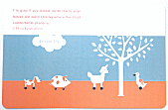 | SER_PM1-14 | Place Mat_Animal | 0.06 | SER | 525YEN
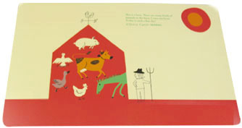 | SER_PM2-40 | Place Mat_barn | 0.06 | SER | 525YEN
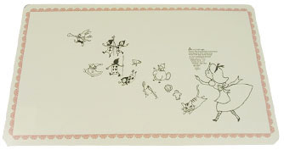 | SER_PM2-30 | Place Mat_alice | 0.06 | SER | 525YEN
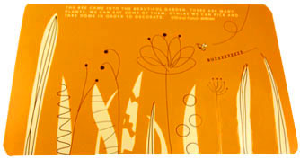 | SER_PM2-26 | Place Mat_bee | 0.06 | SER | 525YEN
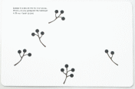 | SER_PM1-04 | Place Mat_Berries | 0.06 | SER | 525YEN
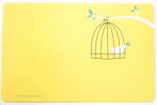 | SER_PM1-05 | Place Mat_Cage | 0.06 | SER | 525YEN
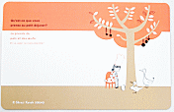 | SER_PM1-15 | Place Mat_Cook | 0.06 | SER | 525YEN
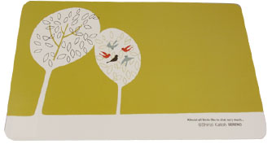 | SER_PM2-39 | Place Mat_chat | 0.06 | SER | 525YEN
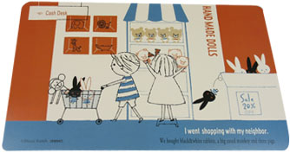 | SER_SPM1-02 | Place Mat Mon Peluche_shopping | 0.06 | SER | 525YEN
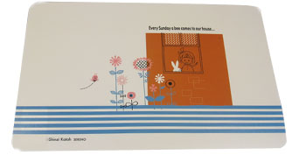 | SER_SPM1-04 | Place Mat Mon Peluche_garden | 0.06 | SER | 525YEN
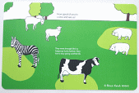 | SER_PM1-13 | Place Mat_Farmyard | 0.06 | SER | 525YEN
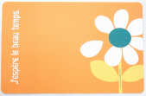 | SER_PM1-01 | Place Mat_Flower | 0.06 | SER | 525YEN
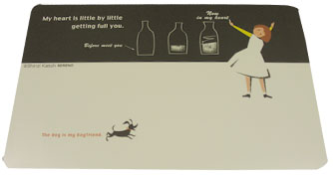 | SER_PM2-34 | Place Mat_girl | 0.06 | SER | 525YEN
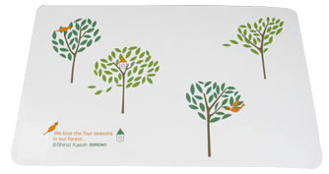 | SER_PM2-22 | Place Mat_four seasons | 0.06 | SER | 525YEN

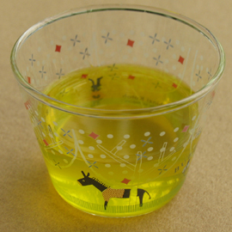 | ROY_RG-19819 | MystyleGlass_dreamy | 0.09 | ROY | 735YEN
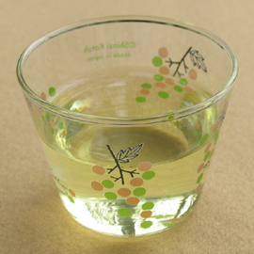 | ROY_RG-19803 | MystyleGlass_grape | 0.09 | ROY | 735YEN
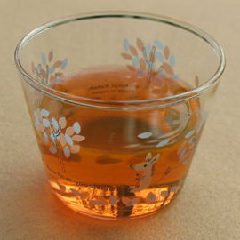 | ROY_RG-19807 | MystyleGlass_HowHaveYouBeen? | 0.09 | ROY | 735YEN
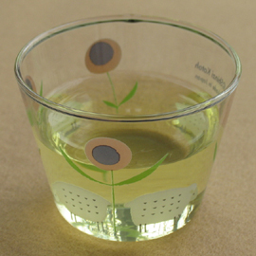 | ROY_RG-19808 | MystyleGlass_mini | 0.09 | ROY | 735YEN
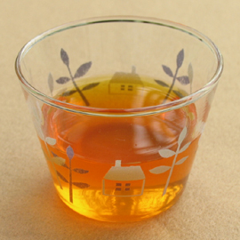 | ROY_RG-19804 | MystyleGlass_MyHome | 0.09 | ROY | 735YEN
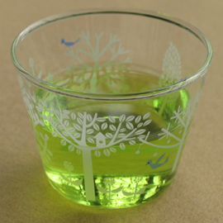 | ROY_RG-19792 | MystyleGlass_PetitBois | 0.09 | ROY | 735YEN
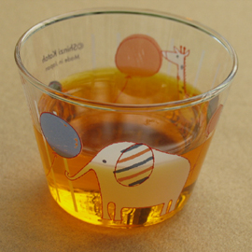 | ROY_RG-19816 | MystyleGlass_puwawa | 0.09 | ROY | 735YEN
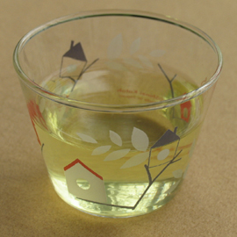 | ROY_RG-19815 | MystyleGlass_UpWard | 0.09 | ROY | 735YEN
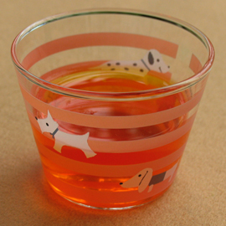 | ROY_RG-19810 | MystyleGlass_dd | 0.09 | ROY | 735YEN
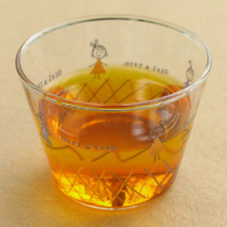 | ROY_RG-19802 | MystyleGlass_girl&girl | 0.09 | ROY | 735YEN

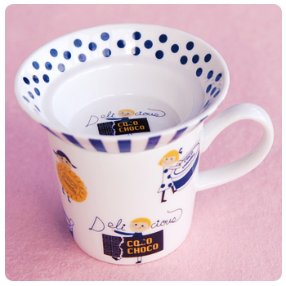 | ANN_71311 | due mug_coco | 0.44 | ANN | 1,365YEN
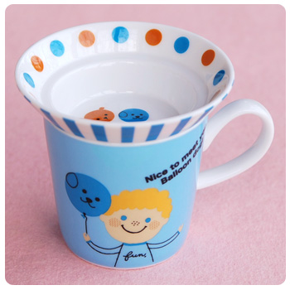 | ANN_71314 | due mug_balloon dog | 0.44 | ANN | 1,365YEN
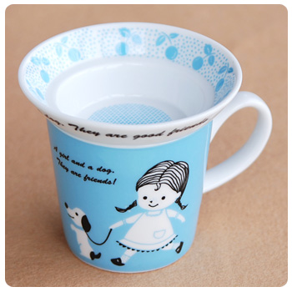 | ANN_71319 | due mug_friends | 0.44 | ANN | 1,365YEN

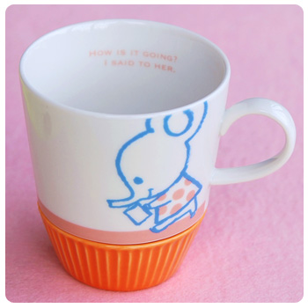 | ANN_71332 | dandan mug_greeting | 0.53 | ANN | 1,260YEN
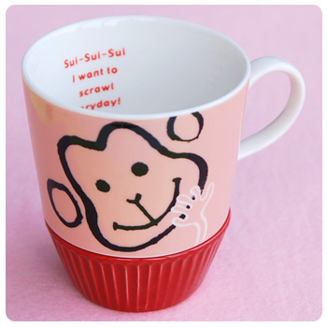 | ANN_71331 | dandan mug_everyday | 0.53 | ANN | 1,260YEN
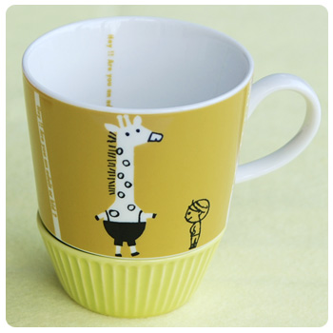 | ANN_71333 | dandan mug_hey! | 0.53 | ANN | 1,260YEN
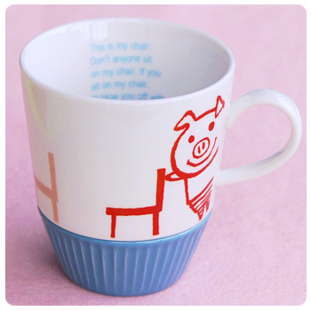 | ANN_71334 | dandan mug_blow | 0.53 | ANN | 1,260YEN

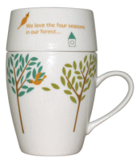 | MAR_CM2008 | CafeMug Colorful_bird tree | 0.40 | MAR | 1,260YEN
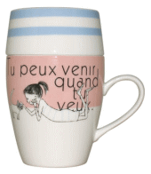 | MAR_CM2001 | CafeMug Colorful_cheri | 0.40 | MAR | 1,260YEN
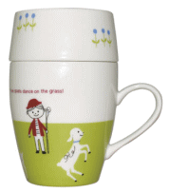 | MAR_CM2009 | CafeMug Colorful_dance | 0.40 | MAR | 1,260YEN
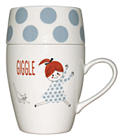 | MAR_CM2004 | CafeMug Colorful_giggle | 0.40 | MAR | 1,260YEN
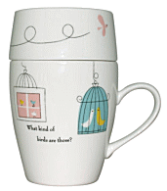 | MAR_CM2000 | CafeMug Colorful_song | 0.40 | MAR | 1,260YEN
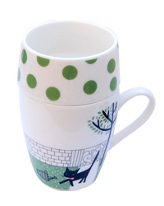 | ZEL_CA-MUG | Mug Cup Treasure Box_CA_Cat | 0.40 | ZEL | 1,365YEN
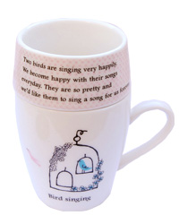 | ZEL_TB-MUG | Mug Cup Treasure Box_TB_Birds | 0.40 | ZEL | 1,365YEN

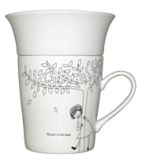 | MAR_CM1900 | CafeMug Monotone_Under The Tree | 0.40 | MAR | 1,260YEN
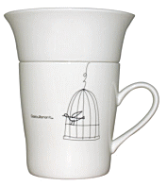 | MAR_CM1901 | CafeMug Monotone_bird cage | 0.40 | MAR | 1,260YEN
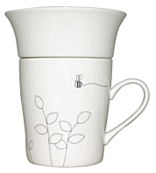 | MAR_CM1912 | CafeMug Monotone_bee | 0.40 | MAR | 1,260YEN
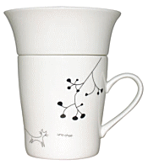 | MAR_CM1909 | CafeMug Monotone_berry and cat | 0.40 | MAR | 1,260YEN

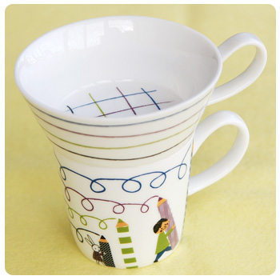 | ANN_71326 | deux mug_scrawl | 0.55 | ANN | 1,575YEN
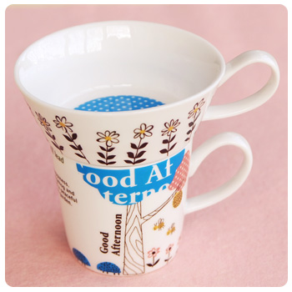 | ANN_71329 | deux mug_good afternoon | 0.55 | ANN | 1,575YEN
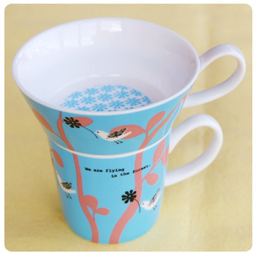 | ANN_71325 | deux mug_forest | 0.55 | ANN | 1,575YEN
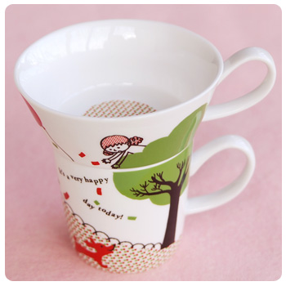 | ANN_71324 | deux mug_above | 0.55 | ANN | 1,575YEN

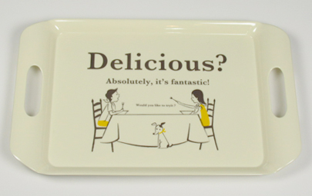 | SER_MT1-14 | Serving Tray_delicious | 0.62 | SER | 2,625YEN 1,890YEN
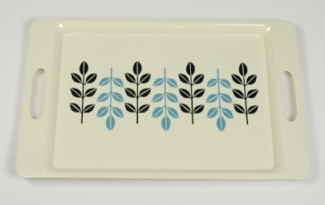 | SER_MT2-19 | Serving Tray_eternal | 0.62 | SER | 2,625YEN 1,890YEN
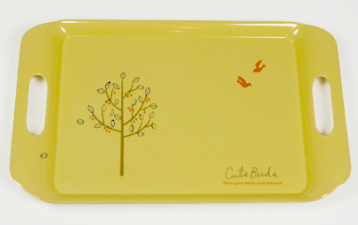 | SER_MT1-01 | Serving Tray_cute birds | 0.62 | SER | 2,625YEN 1,890YEN
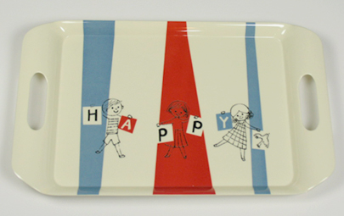 | SER_MT1-15 | Serving Tray_happy | 0.62 | SER | 2,625YEN 1,890YEN
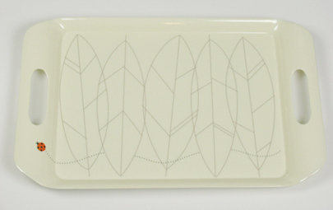 | SER_MT1-05 | Serving Tray_lady bird | 0.62 | SER | 2,625YEN 1,890YEN
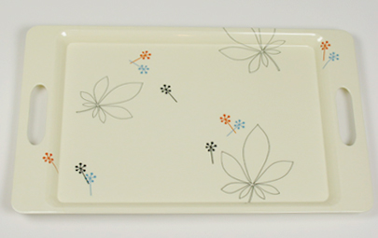 | SER_MT2-20 | Serving Tray_silent | 0.62 | SER | 2,625YEN 1,890YEN
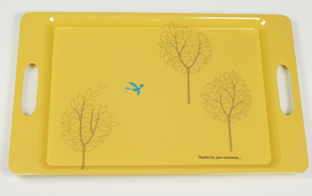 | SER_MT2-25 | Serving Tray_thanks | 0.62 | SER | 2,625YEN 1,890YEN
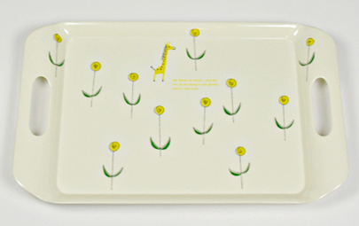 | SER_MT1-02 | Serving Tray_small garden | 0.62 | SER | 2,625YEN 1,890YEN
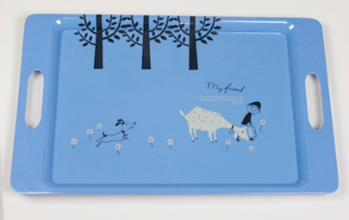 | SER_MT2-29 | Serving Tray_myfriend | 0.62 | SER | 2,625YEN 1,890YEN

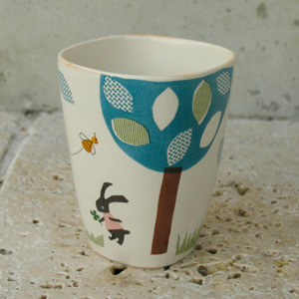 | YAN_SK-122 | Hutte_Cup | 0.20 | YAN | 840YEN
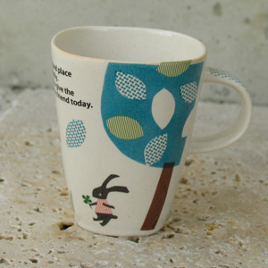 | YAN_SK-120 | Hutte_Mug | 0.20 | YAN | 1,050YEN
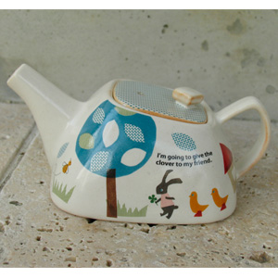 | YAN_SK-124 | Hutte_Pot | 0.50 | YAN | 2,940YEN
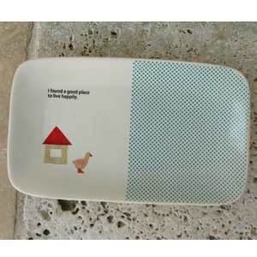 | YAN_SK-123 | Hutte_SQUAREPlate | 0.40 | YAN | 1,260YEN

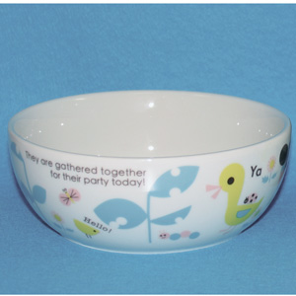 | YAN_SK-324 | Mon Enfant Party_Bowl | 0.30 | YAN | 945YEN
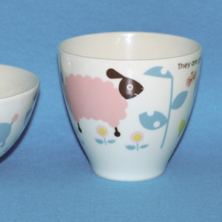 | YAN_SK-323 | Mon Enfant Party_Cup | 0.15 | YAN | 735YEN
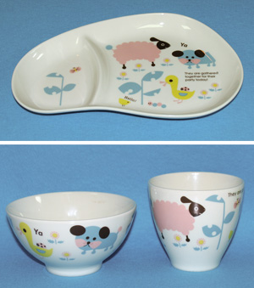 | YAN_SK-330 | Mon Enfant Party_SET | 0.75 | YAN | 3,150YEN
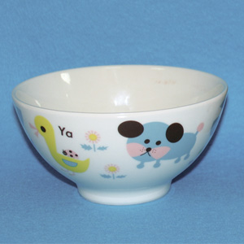 | YAN_SK-322 | Mon Enfant Party_Rice Bowl | 0.20 | YAN | 840YEN

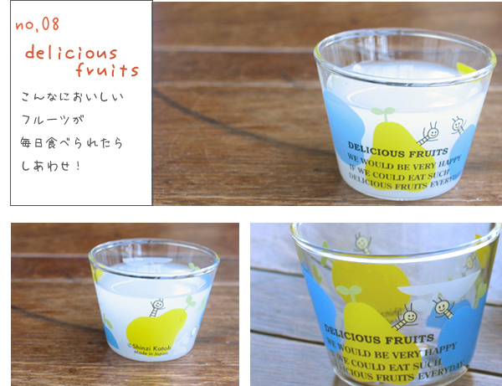 | ROY_RG19828 | Pudding Cup_fruits | 0.07 | ROY | 630YEN
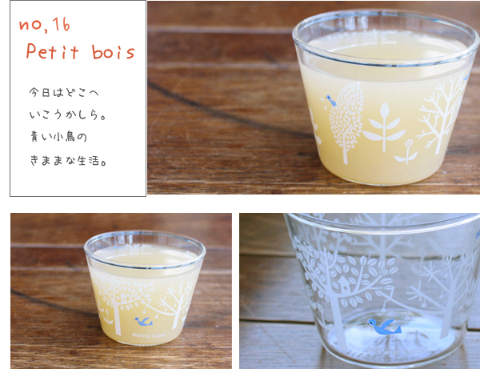 | ROY_RG-19790 | Pudding Cup_petit bois | 0.07 | ROY | 630YEN
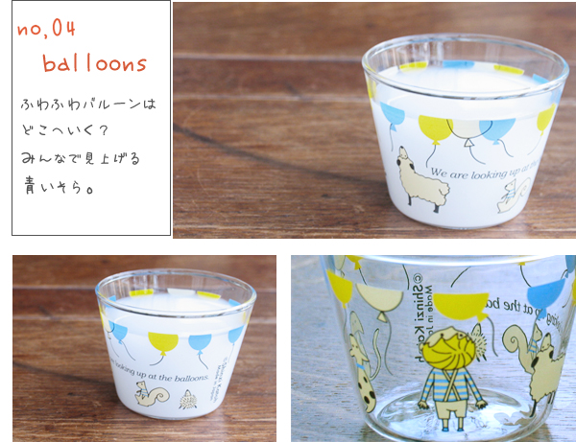 | ROY_RG19824 | Pudding Cup_balloons | 0.07 | ROY | 630YEN
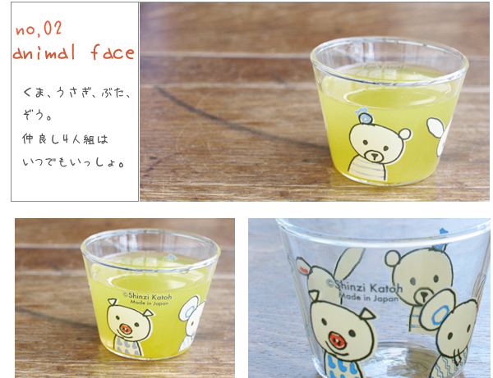 | ROY_RG19822 | Pudding Cup_animal face | 0.07 | ROY | 630YEN
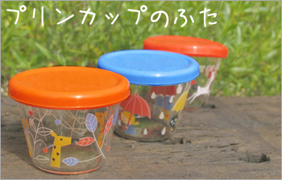 | ROY_RG-19843 | Pudding Cup LID:Bule | 0.01 | ROY | 189YEN

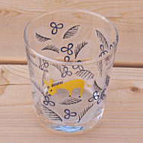 | SER_GW1-09 | Glass Cup Tiny Donkey | 0.20 | SER | 525YEN
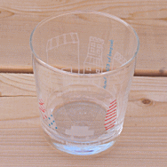 | SER_GW1-02 | Glass Cup Trip | 0.20 | SER | 525YEN
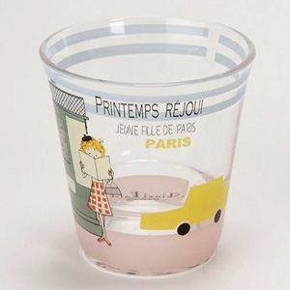 | SEK_882560 | Short Tumbler PRINTEMPS REJOUI_Voyage | 0.20 | SEK | 924YEN
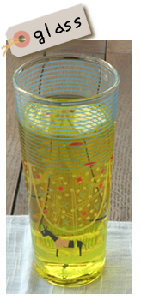 | ROY_RG-20076 | Tall Glass_dreamy | 0.15 | ROY | 945YEN
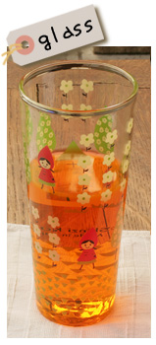 | ROY_RG-20073 | Tall Glass_little girl | 0.15 | ROY | 945YEN
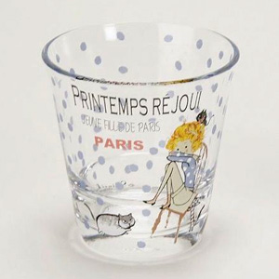 | SEK_882570 | Short Tumbler PRINTEMPS REJOUI_Room | 0.20 | SEK | 924YEN

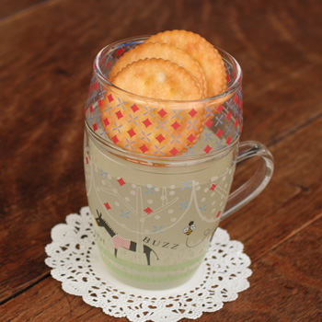 | ROY_RG-20030 | GlassCafeMugSet_dreamy | 0.20 | ROY | 1,470YEN
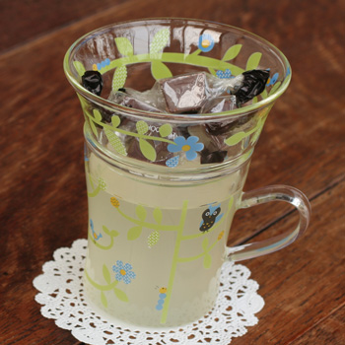 | ROY_RG-20026 | GlassCafeMugSet_green house | 0.20 | ROY | 1,470YEN
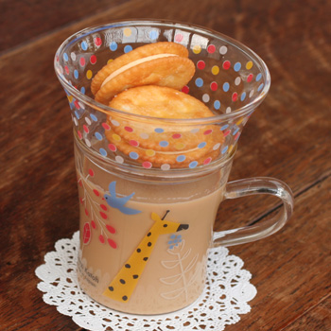 | ROY_RG-20023 | GlassCafeMugSet_kirin | 0.20 | ROY | 1,470YEN
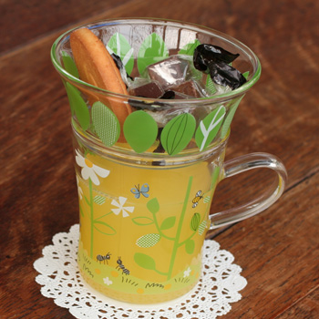 | ROY_RG-20022 | GlassCafeMugSet_small talk | 0.20 | ROY | 1,470YEN
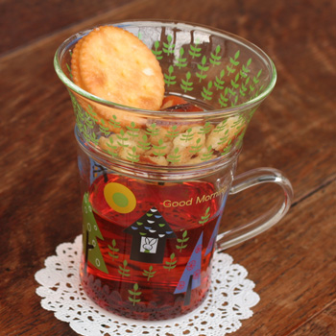 | ROY_RG-20025 | GlassCafeMugSet_wood | 0.20 | ROY | 1,470YEN
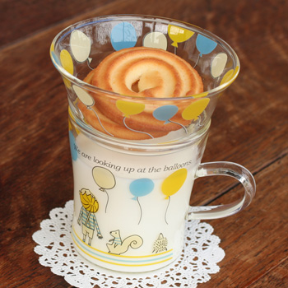 | ROY_RG-20024 | GlassCafeMugSet_balloons | 0.20 | ROY | 1,470YEN
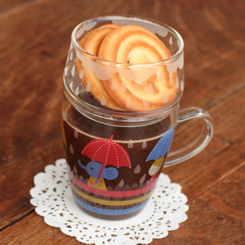 | ROY_RG-20031 | GlassCafeMugSet_umbrella | 0.20 | ROY | 1,470YEN

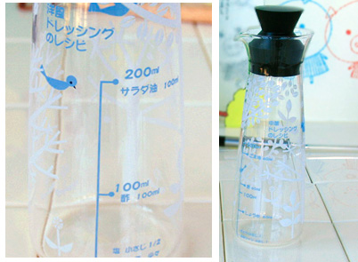 | ROY_RG-19780 | Dressing Bottle Petit Bois Western | 0.30 | ROY | 1,680YEN
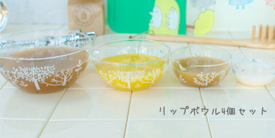 | ROY_RG-19742 | Petit Bois Lip Bowl 4set | 0.50 | ROY | 4,200YEN
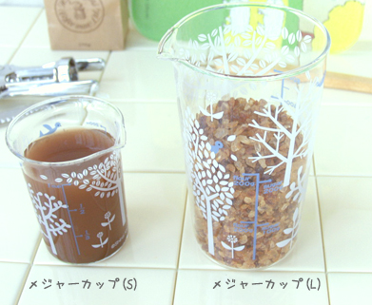 | ROY_RG-19762 | Petit Bois Measure Cup L | 0.30 | ROY | 1,260YEN
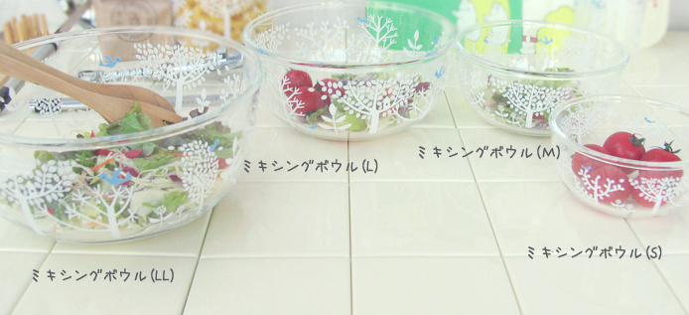 | ROY_RG-19750 | Petit Bois Mixing Bowl S | 0.42 | ROY | 1,050YEN
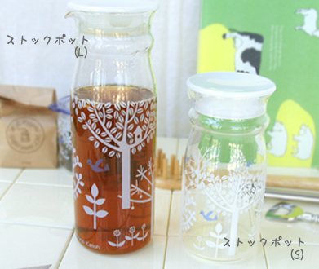 | ROY_RG-19703 | Petit Bois Stock Pot[S] | 0.30 | ROY | 1,155YEN
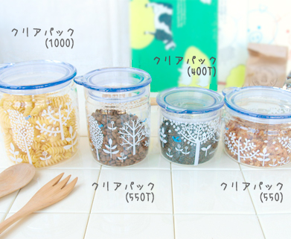 | ROY_RG-19712 | Petit Bois ClearPack1000 | 0.55 | ROY | 1,680YEN

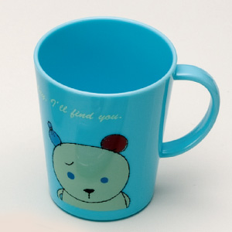 | SEK_880600 | Plastic Cup Someday,I'll find you._Hello! | 0.10 | SEK | 525YEN
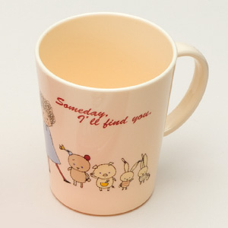 | SEK_880610 | Plastic Cup Someday,I'll find you._Introduce | 0.10 | SEK | 525YEN

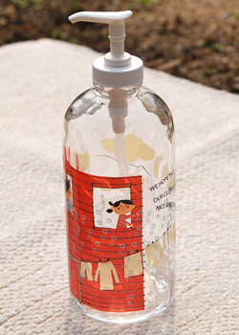 | ROY_RG-20154 | Lotion Bottle_laundry | 0.48 | ROY | 1,890YEN
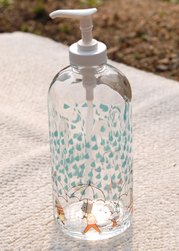 | ROY_RG-20156 | Lotion Bottle_rainy | 0.48 | ROY | 1,890YEN
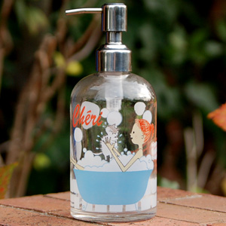 | SER_LB1-20 | ShampooBottle_cheri | 0.48 | SER | 2,100YEN
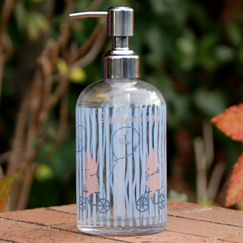 | SER_LB1-03 | ShampooBottle_quartet | 0.48 | SER | 2,100YEN
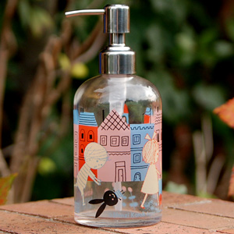 | SER_LB1-23 | ShampooBottle_mon peluche | 0.48 | SER | 2,100YEN
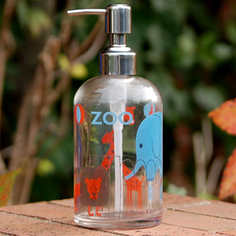 | SER_LB1-18 | ShampooBottle_holiday | 0.48 | SER | 2,100YEN

